<https://www.youtube.com/watch?v=40X6abe5wv0&list=PLVz2XdJiJQxxurKT1Dqz6rmiMuZNdClqv&index=23>

* **Deploy Your Angular Applications into AWS S3**
* Angular Production build
* Upload files in dist folder to s3 buket,
* Give file permission permission as public
* Go to actions => web site hosting => specify welcome page ( index.html )
* Then AWS give url for our static website.
* **Deploy Spring Boot Applications | AWS Elastic Beanstalk | Tomcat**

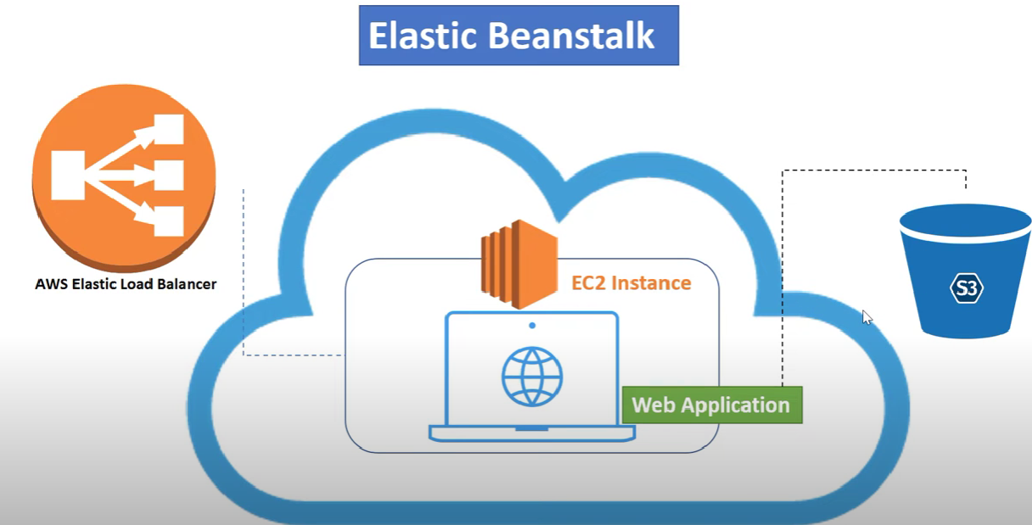

1. Go To AWS console => Elastic Bean stock
2. Give application name
3. Choose platform => Tomcat
4. Choose Java version
5. Upload code => choose war file => create application
6. In console we can observe, creating EC2 instance, setting environment
7. Deployed our application in Elastic bean stock, will show Application Health status & url
8. Elastic Bean stock will take care of creating EC2 instance, upload war/jar into S3 bucket for deployment, setting environment.

* **AWS DynamoDB | Spring Boot CRUD Example Deployed in Elastic Beanstalk.**

1. AWS Console => Service => Dynamo DB (Managed NoSQL Database)
2. Create Table => give name => specify primary key/Partition key/Hash Key => create.
3. Services => IAM => Create a Group => <group name> => Attach Policy ( AdministrationAcess,AmazonEC2FullAcess )=> Create Group.
4. Add User => <user_name> => Access type => Programmatic access => Assign user to group => create user=> we get Access key ID, Secret acess key.
5. Go to IAM=> Policies => create policy => click json => add policy json => give policy name=>create policy
6. Attach above created policy to group.
7. Now we create spring boot app => add starter in pom “aws-java-sdk-dynamodb”

**Amazon RDS | Deploy Spring Boot + MySQL CRUD Application into Elastic Beanstalk**

Amazon console => services => RDS => Databases => Create DataBase => choose database ( eg.mysql) => choose free tier / others => give db name => choose username, pwd => additional connectivity ( public connectivity ) => Databse options ( choose <Schema_name> - database name ) => create database.

Copy db endpoint and keep it in our springboot app inplace of databse url ip address.

Security => Inbound Rules => Edit Inbound rules => Add Rules => Custom TCP ( Mysql ) => port 3306 => source ( anywhere ) => save rules.

Deploy SpringBootApp with Amazon mysql RDS => AWS Services => Elastic Beanstalk => Create Application => give application name => choose plat form and version => Configure more options => Dataabase => Edit database => give RDS credential which is in aws ( username, password ) => create the application => Upload Jar => deploy => access application using aws given link.

**Spring Boot | Manage your credentials using AWS Secrets Manager**

AWS Console => AWS Secrets Manager => store a new secret => choose RDS => username,password => select the encryption=> choose one from our db list => db credential name, give any description = > any additional key,value if any => click on Next => automatic rotation => review => shows the code

Language specific ( copy java snippt ) => store.

In our springboot app

@Configuration

Public class ApplicationConfig{

<past code>

}

Add dependency in pom.xml ( gson, aws-java-sdk-secretmanager )

Create DTO AWSSecrets

Public class AwsSecrets{

Private String username;

Private String password;

Private String host;

Private String engine;

Private String port;

Private String dbInstanceIdentifier;

}

**Spring Cloud AWS | Amazon Simple Queue Service | SQS**

Aws Console => Services => Simple Queue Service => Create a Queue => Statdard Queue / FIFO Queue => give Queue name => create queue => copy url

=> create group => give the name=> administrator & amzonfull acess=>create new user=> give name=> give programmatic access => attach group to user => copy ( access key ID, Secret access key)

* Some high-volume scenario, Standard Queue may deliver duplicate message. ( result data inconsistency)
* But in FIFO once message is process first in first out manner, once the message is processed it will be deleted.

Create Spring boot app with pom dependency

Spring-cloud-starter-aws, spring-cloud-starter-aws-messaging

***AWS SNS is also there like SQS.***

**Spring Cloud AWS | Amazon Simple Notification Service | SNS**

AWS Services => Simple Notification Service => Give Topic Name => Give Display name => Create Topic.

Use Cases:

<https://stackabuse.com/spring-cloud-aws-sns/>

My Security Credentials => console top right corner to get Access key, secret key.

Create Spring boot App => add dependency ( AWS Cord, AWS Simple Queue Service )

**Spring Boot Serverless Architecture using AWS Lambda | Spring Cloud Function**

* Zero Server Management
* Flexible Scaling
* No Idle Capacity ( Pricing is pay-as-you-go )

AWS Lambda -> Serverless Programming

* AWS Lambda is s serverless computing service provided by Amazon to reduce the configuration of servers, OS.
* ASW Lambda lets you run code without provisioning or managing servers—it scales automatically and only charges for the time your code is running.

Where to use

* When you want to expose a web endpoint, a Stream processor, or a task to cloud without depending on server and OS

**Trigger Spring Cloud Function on AWS Lambda using API Gateway**

**https://www.youtube.com/watch?v=btfnLVflOuc&list=PLVz2XdJiJQxxurKT1Dqz6rmiMuZNdClqv&index=13**

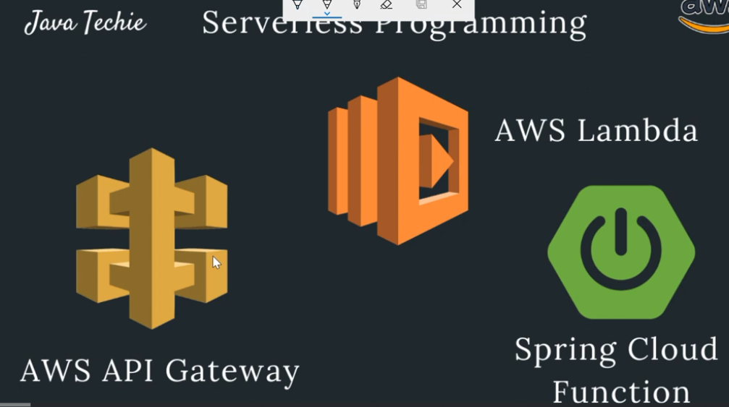

* AWS console
* Seach Lambda => create Function => Choose Environment ( java 1.8 ) => Go to Edit Environment => add FUNCTION_NAME - <function-name>, add handler class of our springboot project with fulli qualified name.
* Add Trigger => API Gateway =>create an API=> security ( open ) => HTTP
* Take the url and try

**Amazon API Gateway | Access Your Spring Boot Microservice**

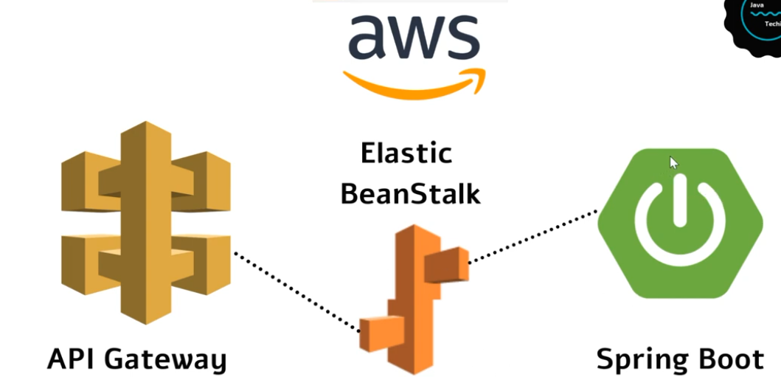

Aws Console => Elastic Bean stock => Create new environment => Web server environment => give application name => select environment ( run time ) => Select Domain ( check availability for custome domain ) => choose platform => upload code => choose file => create environment.

API Gateway

AWS Services => API Gateway => Create API => Rest API => Build => New API => API Name, description Endpoint type ( Regional ) => Create API => Actions ( Create Resource ) ( specify root url ) => Actions (create method ) => Give base url which we get in elastic bean stock => Actions ( deploy API )

<https://www.youtube.com/watch?v=3iwItfr4N38&list=PLVz2XdJiJQxxurKT1Dqz6rmiMuZNdClqv&index=14>

**Run Spring Boot Docker image on AWS ECS | Amazon Elastic Container Service**

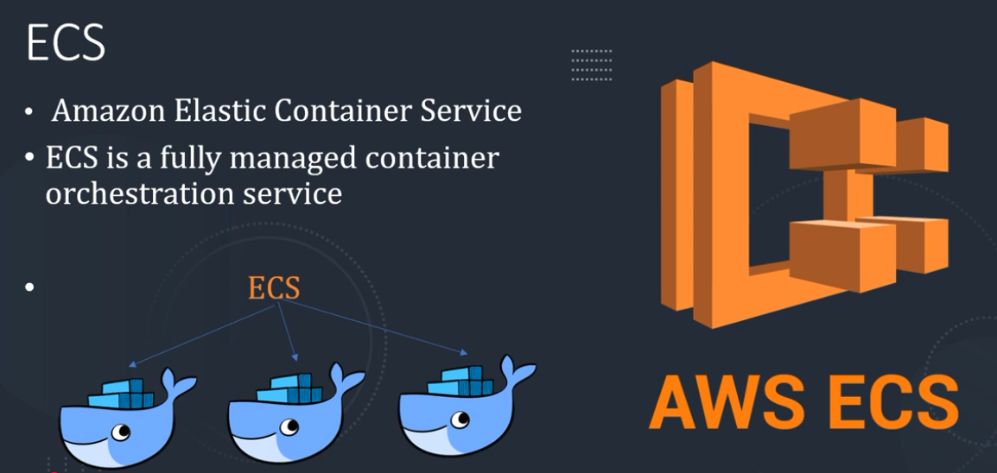

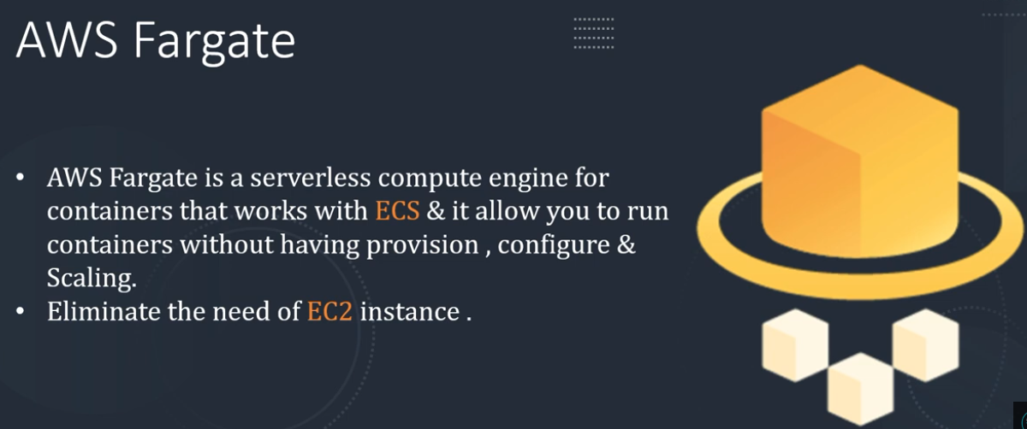

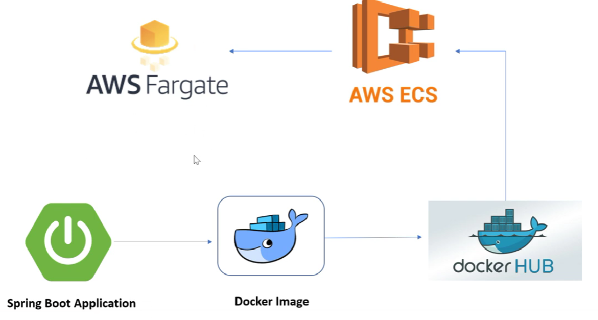

Create docker image of our spring boot application

Before run below command , open docker terminal

>mvn spring-boot:build-image

View all docker images

* docker image ls

Run image

* Docker run -tty –publish 8080:8080 <docker-image-name>

Tag image with name

* Docker tag <image-name> <name>/<image-name>

Push image to docker hub.

* Docker push <name>/<image-name>

AWS Console => ECS ( Elastic container service ) => Task Definition => create new task definition => Select launch type compatibility ( FARGATE ) => Give Task Definition Name => Choose Role ( None ) => Specify Task Memory ( eg: 1GB ) , Task CPU ( eg: 0.5) => Add Container ( Container Name, Image name ( docker.io/docker image full name in docker hub ), Select Memory limit => Port Mapping ( 8080,80) => Add => Create.

Click on Clusters => create Cluster => Network Only => Enter Cluster Name => Create.

Run New Task => Launch type FARGOT => select already created task => Select Cluster VPC default => Select subnet => Security group => Edit => Add new Security => security name=> All TCP, All Traffic => Click on Cluster Task => Take IP Address => Access IP Address:8080/

**Amazon ECR | Elastic Container Registry | Run Docker image on AWS ECS**

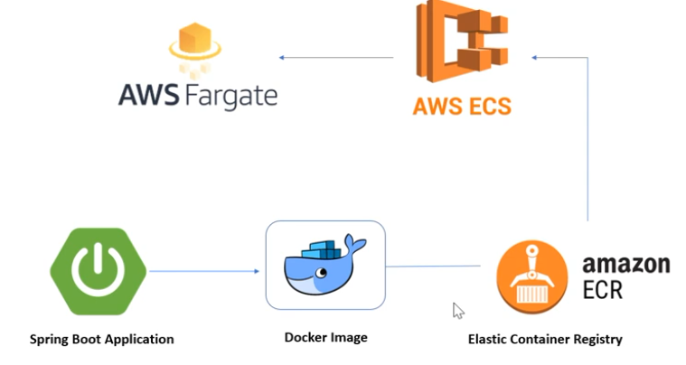

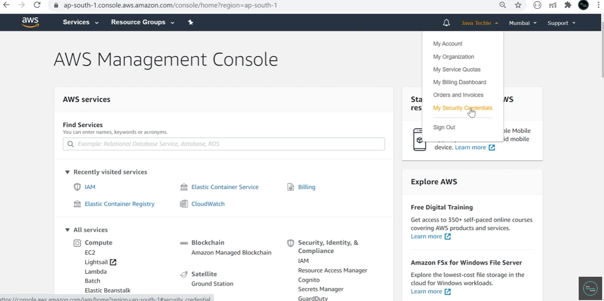

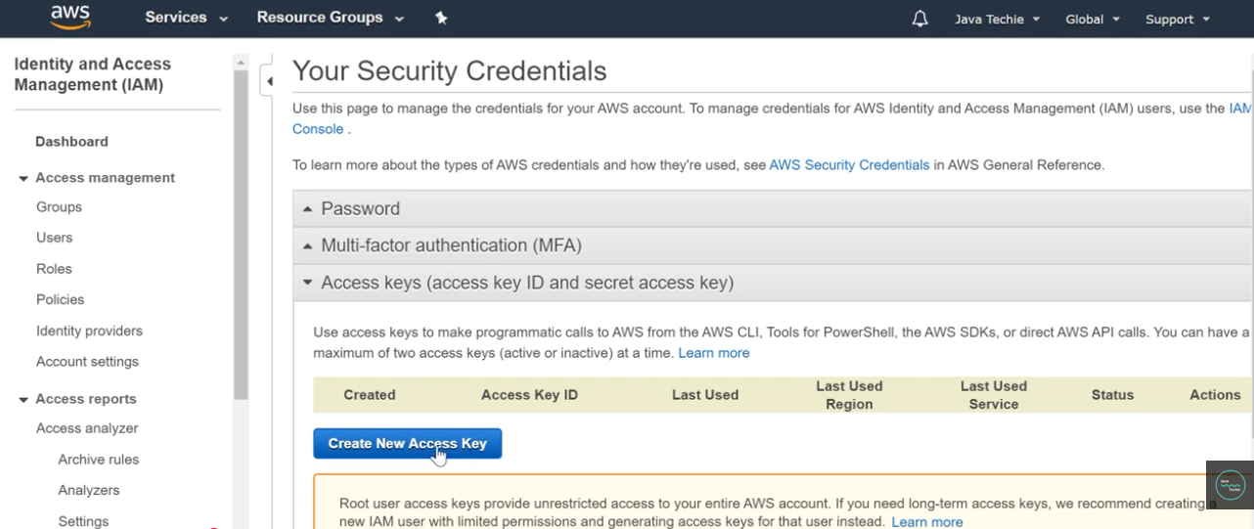

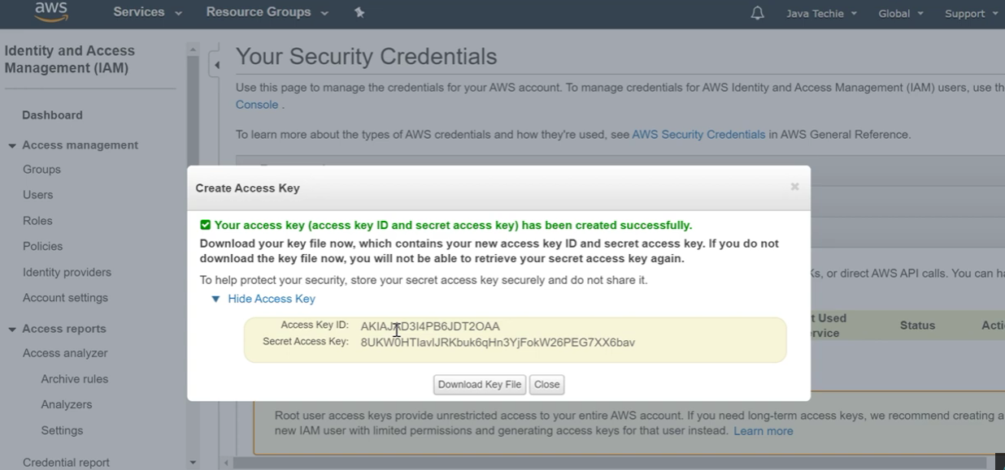

Install AWS CLI

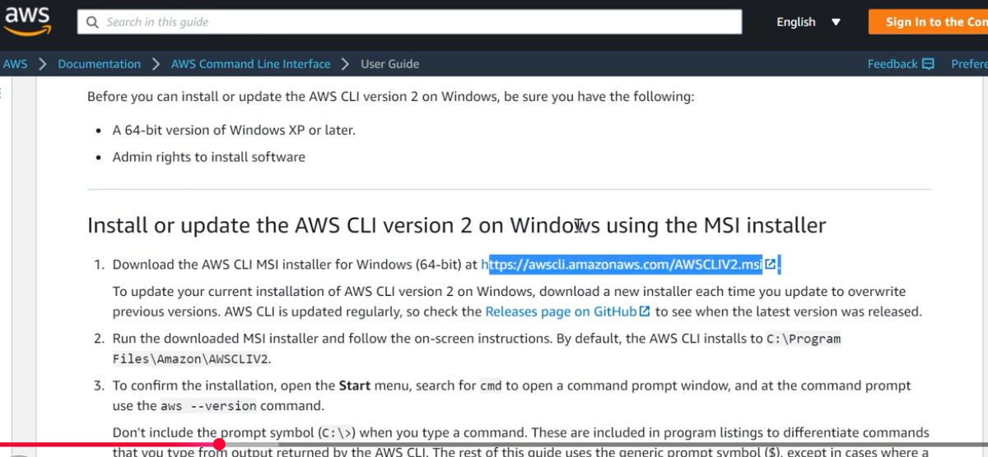

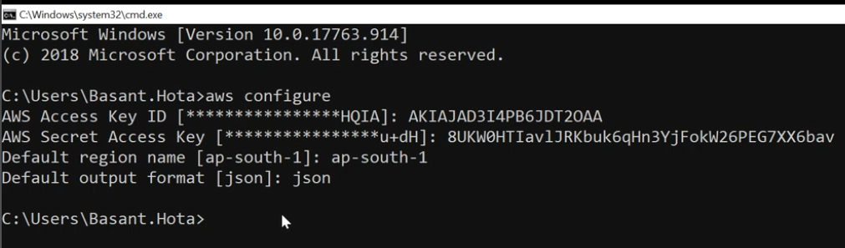

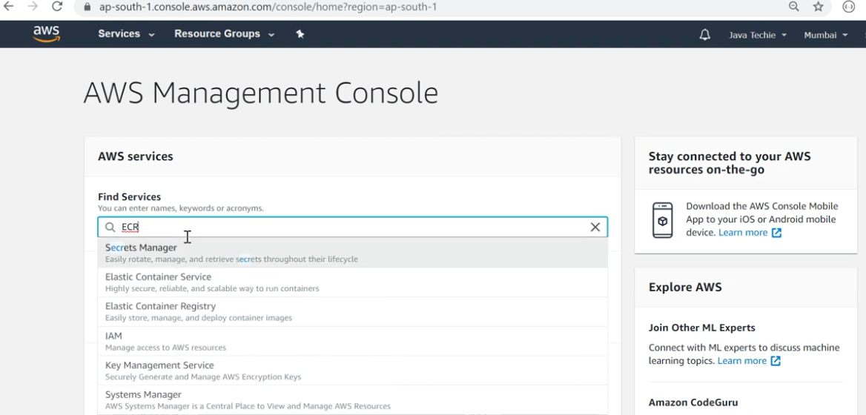

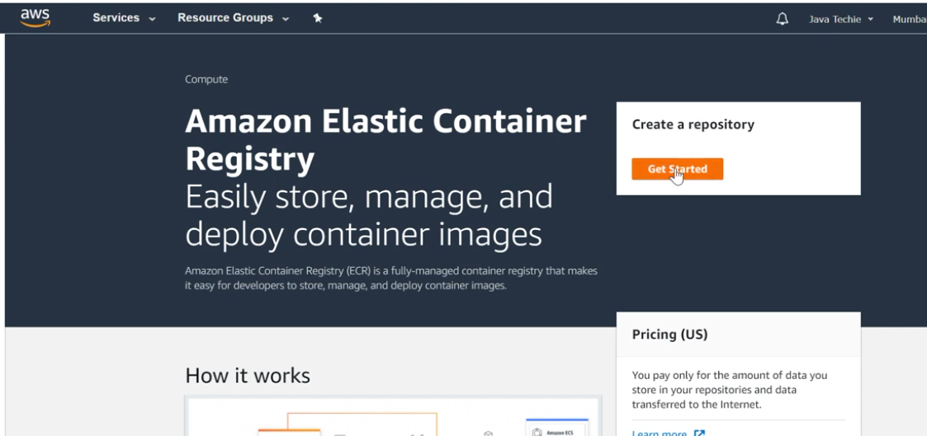

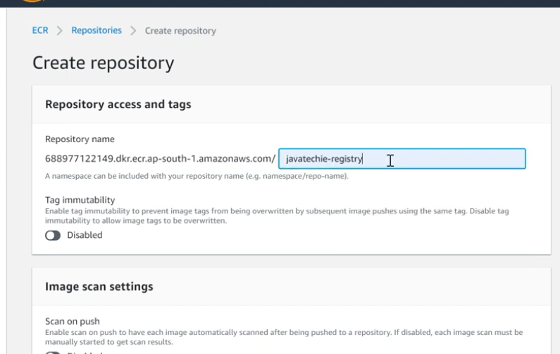

Copy URI

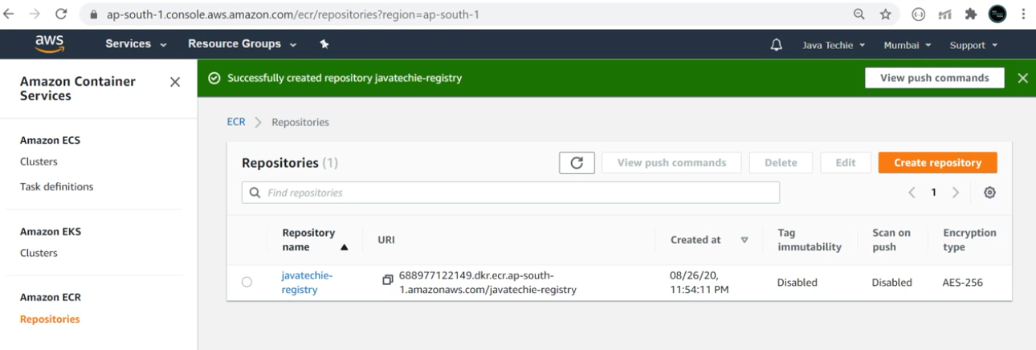

ECR Login from CLI

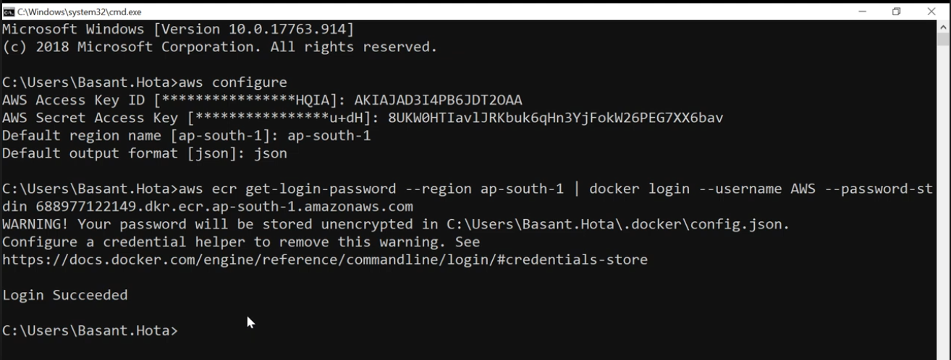

Tag Docker Image to ECR

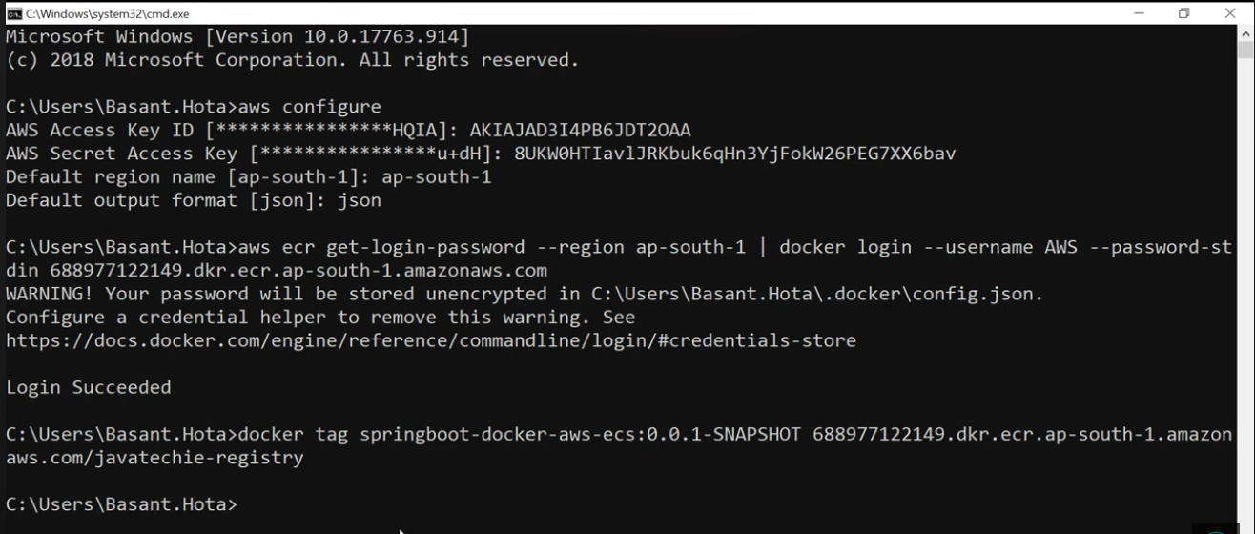

Push Image to ECR

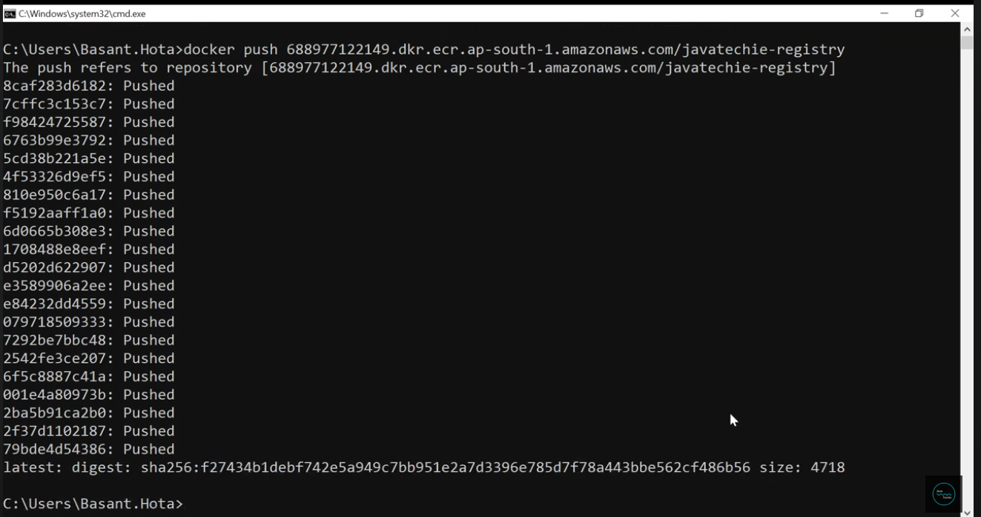

Then like in Previous Session

Task Definition

Clusters

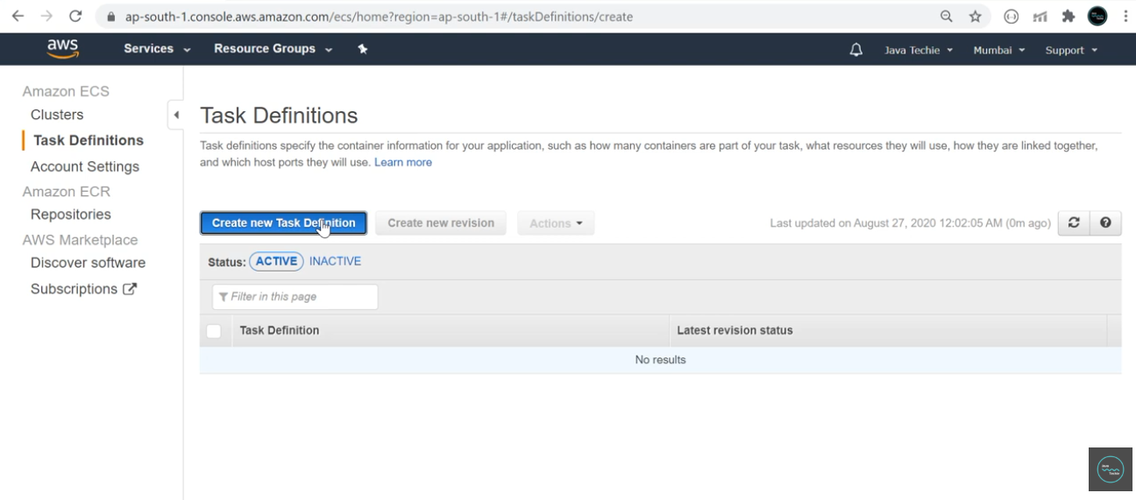

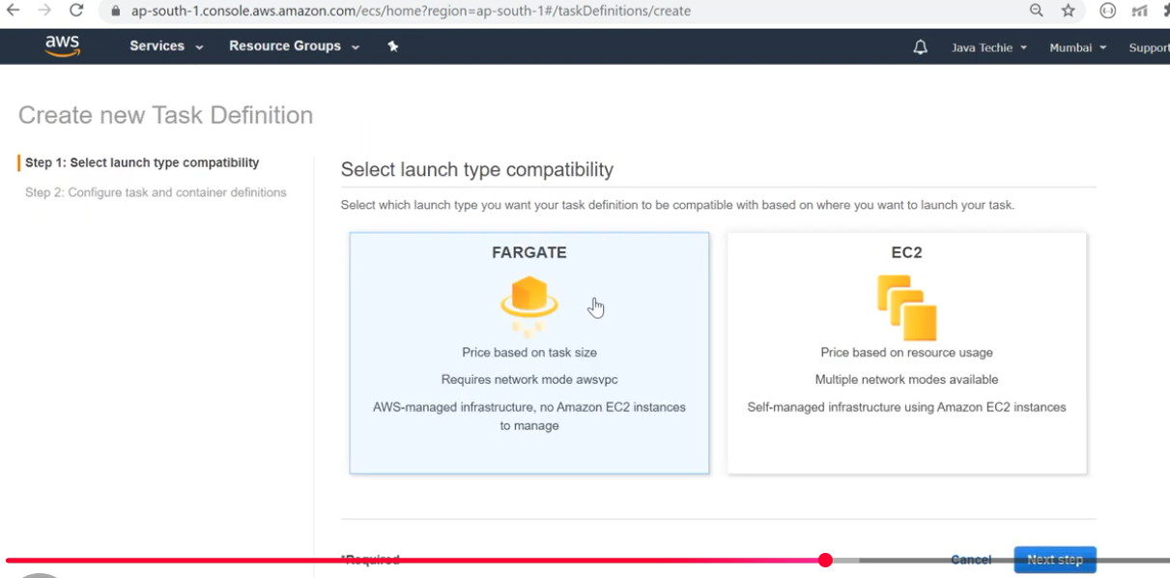

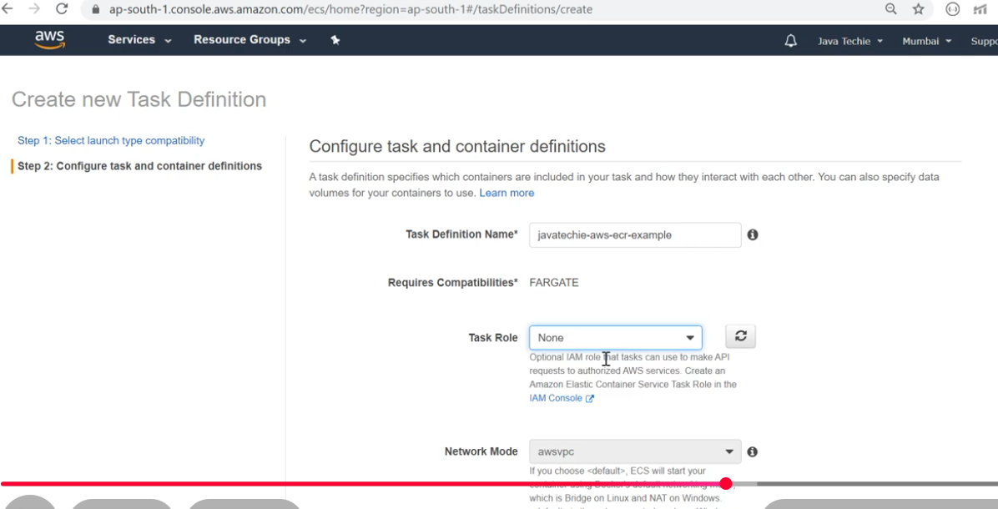

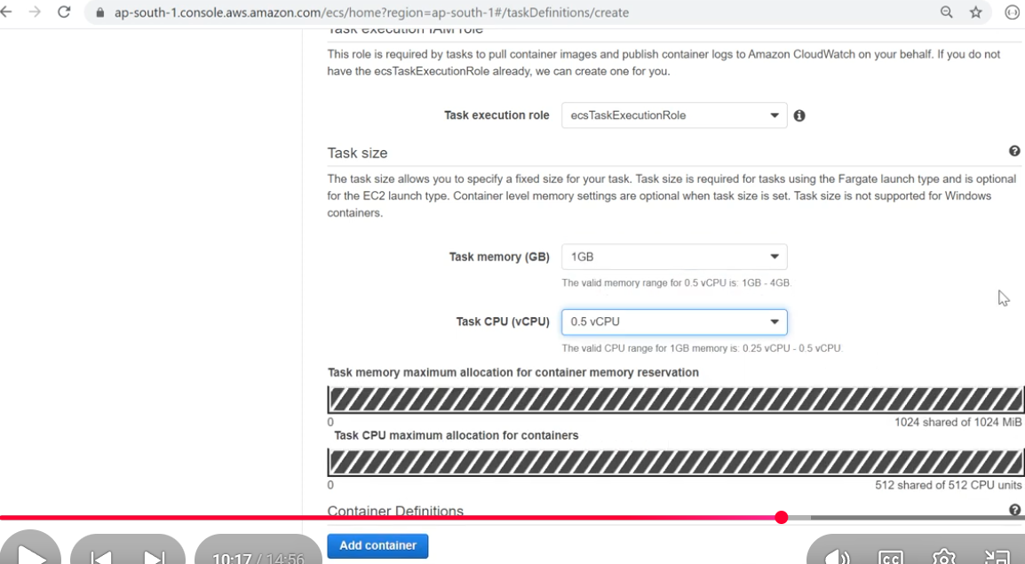

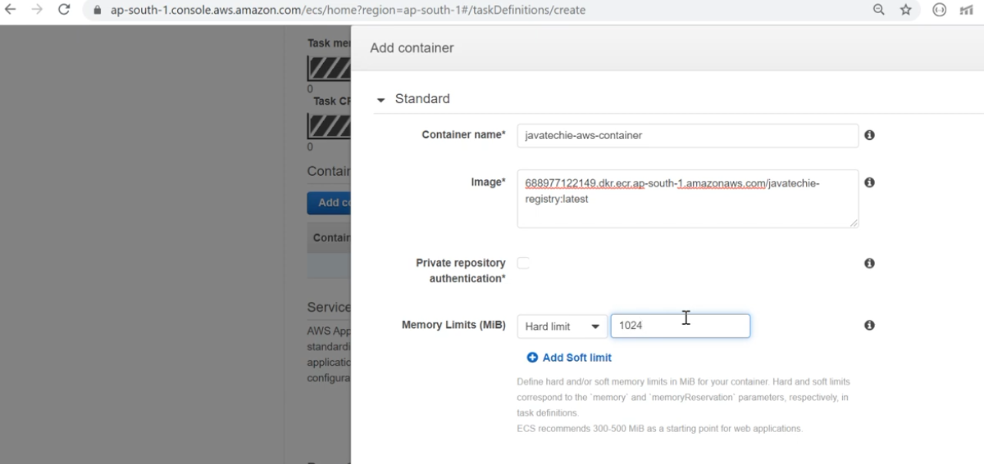

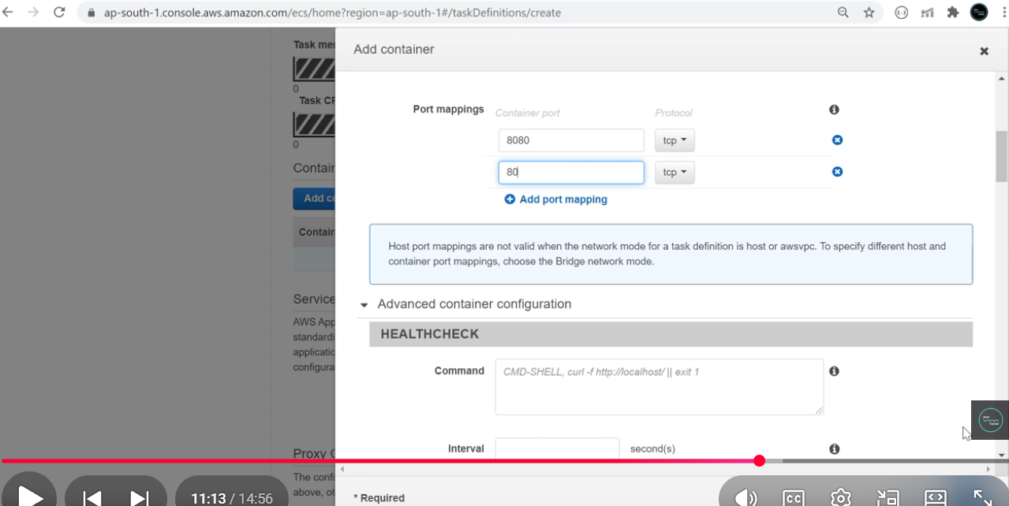

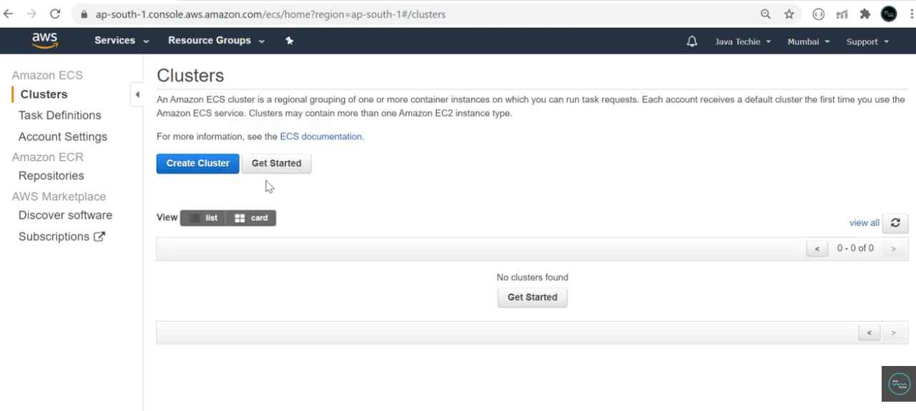

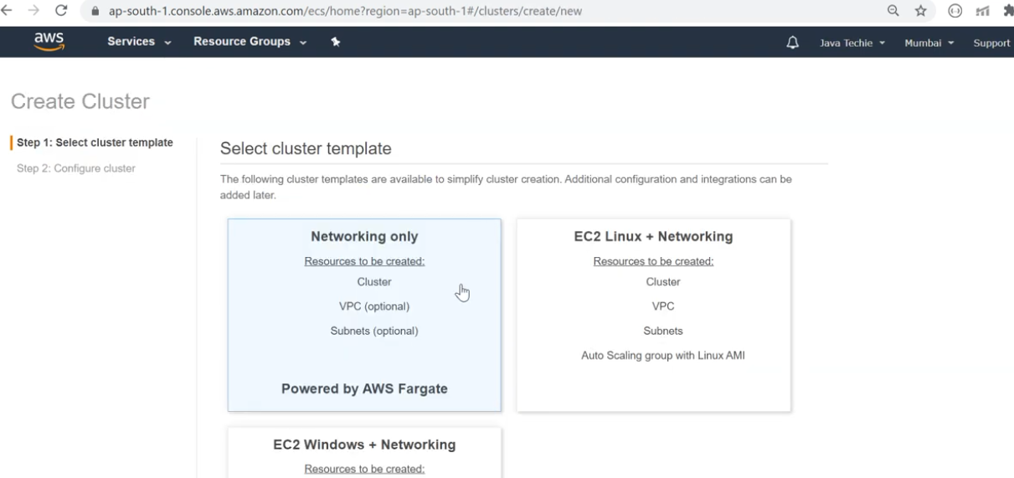

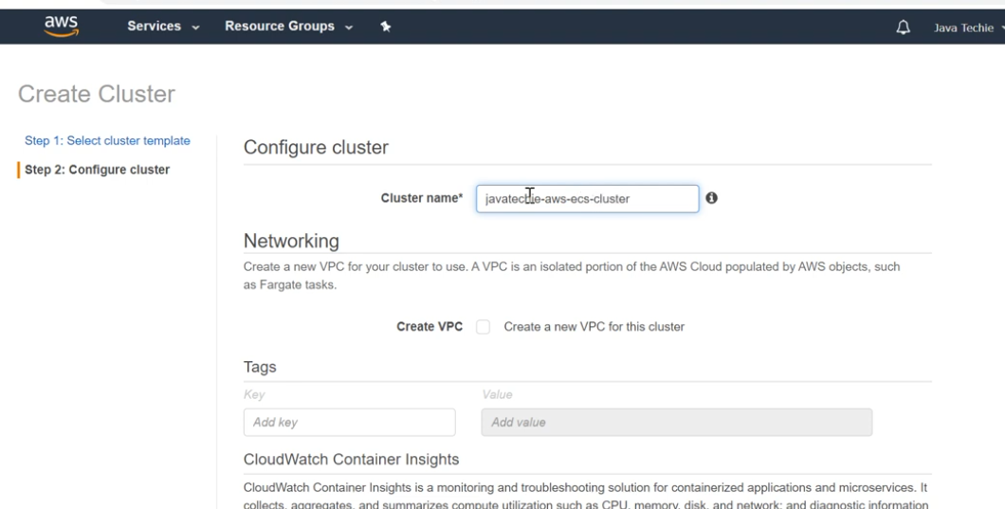

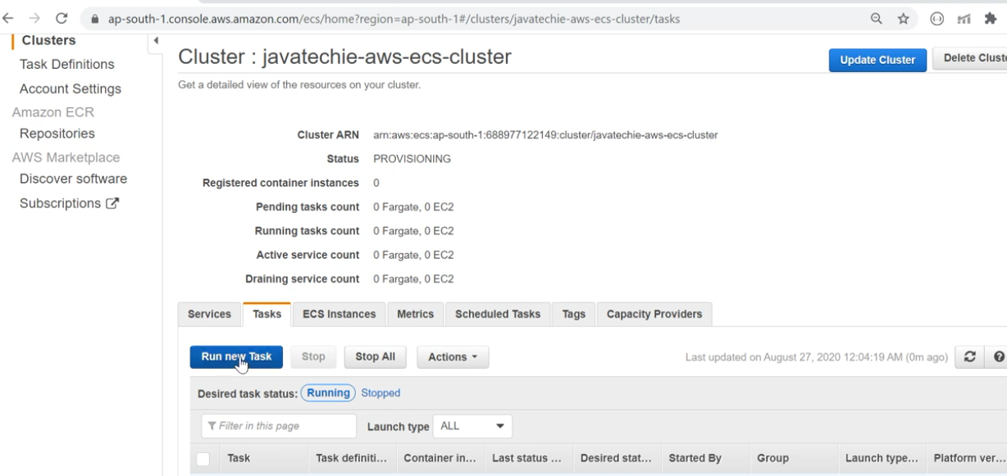

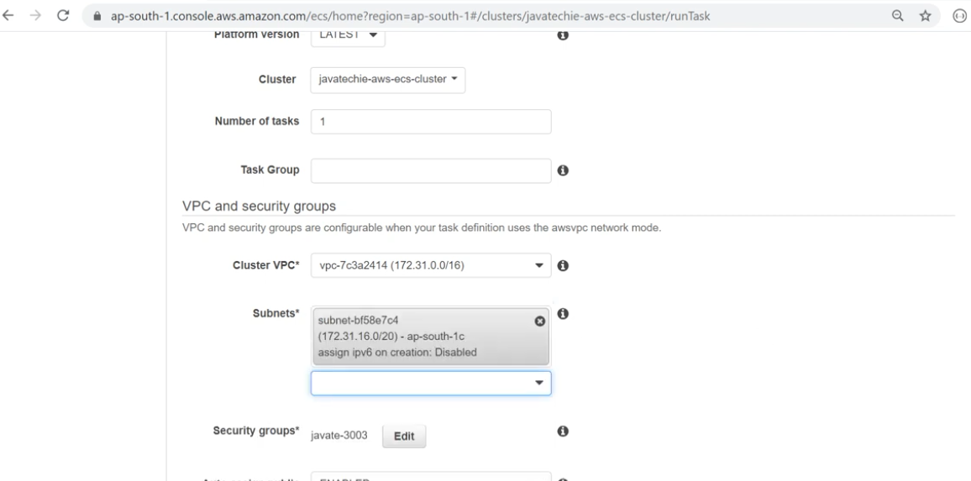

Add Security group

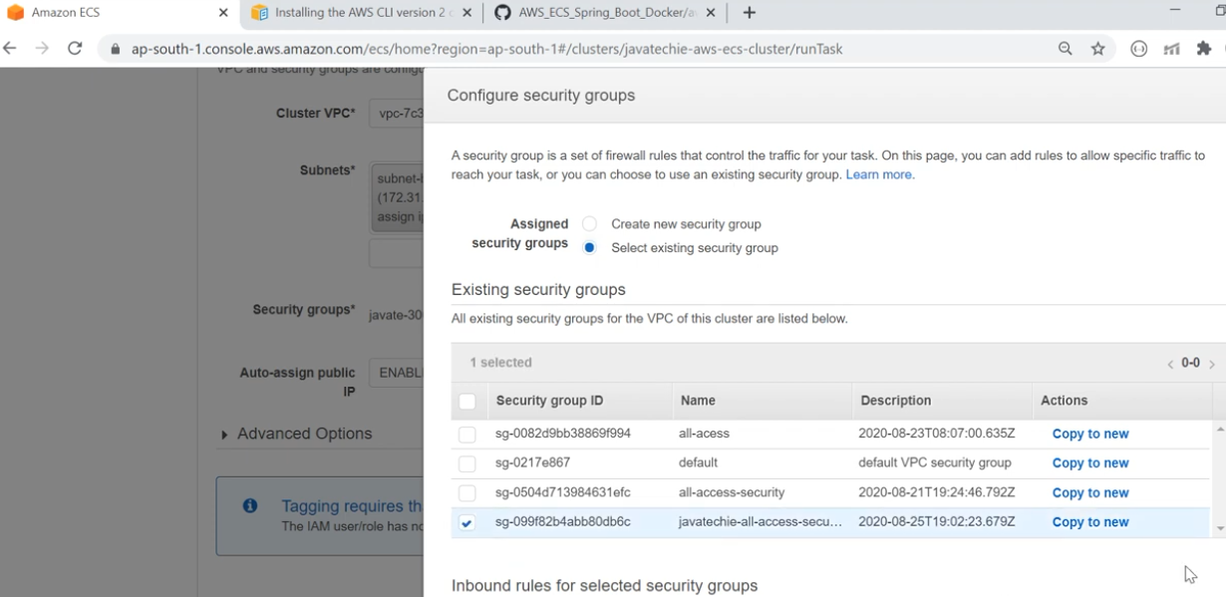

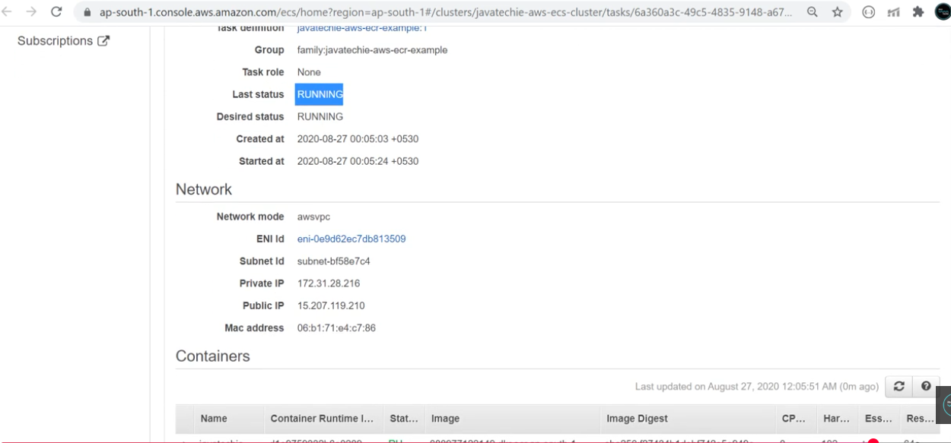

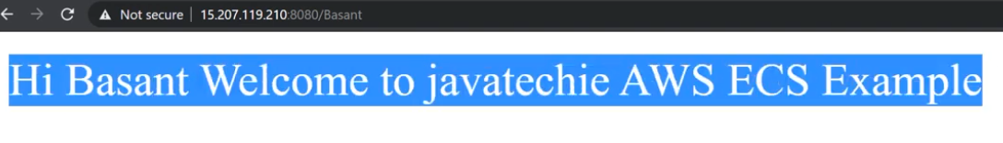

**AWS DevOps | Build a CI/CD in AWS using CodePipeline & CodeBuild**

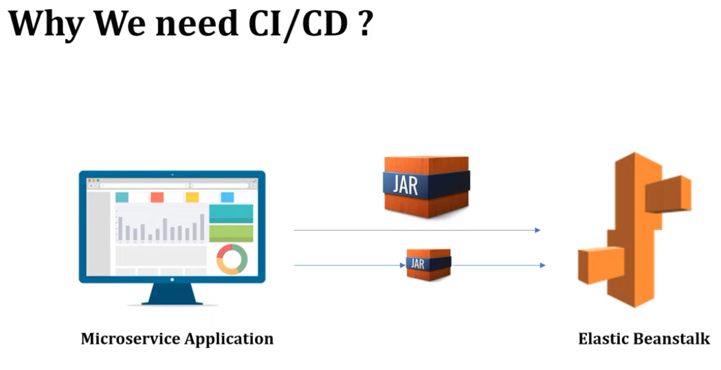

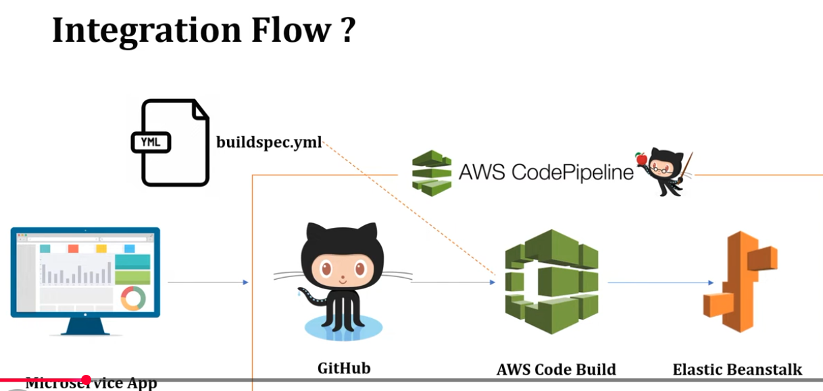

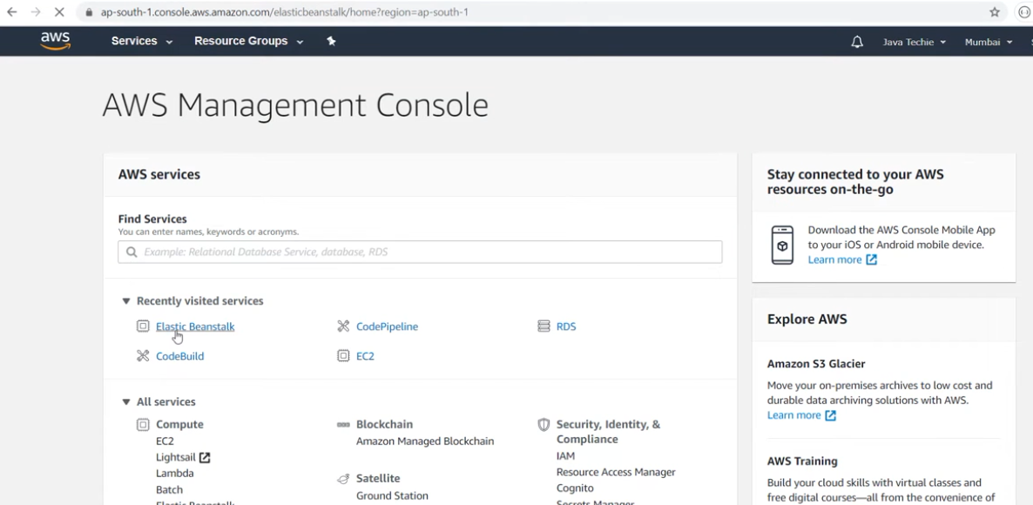

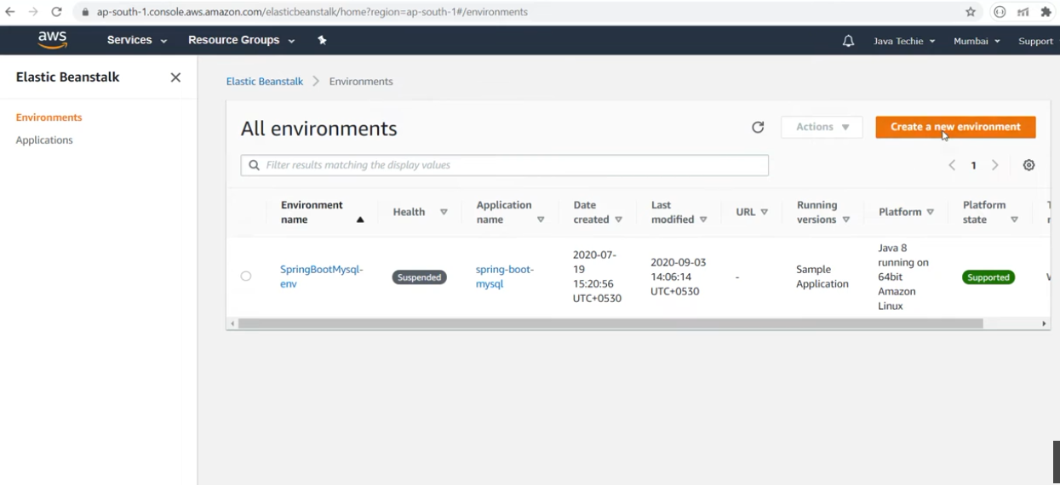

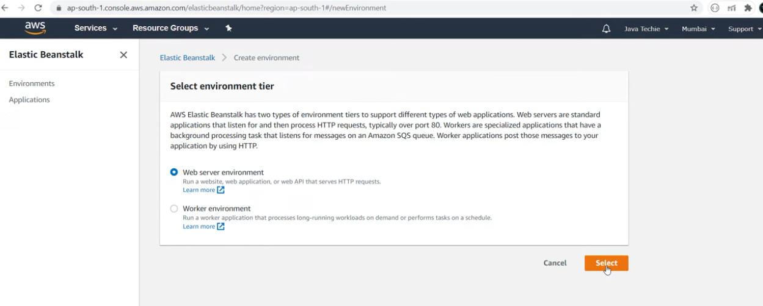

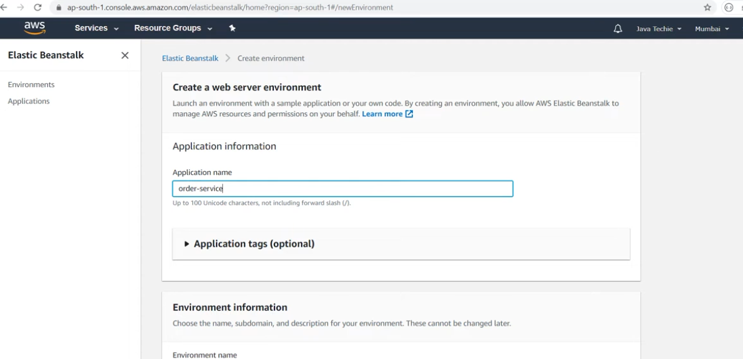

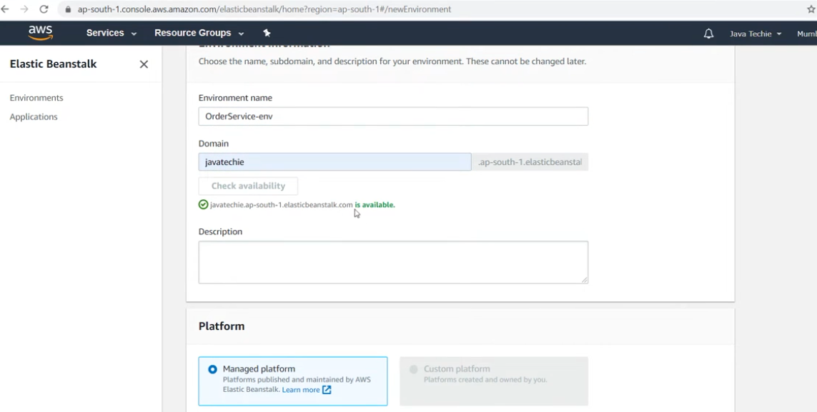

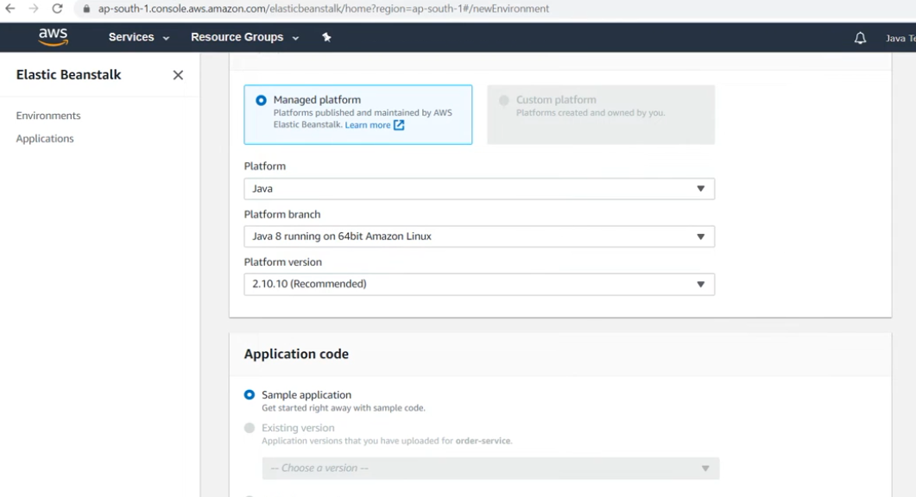

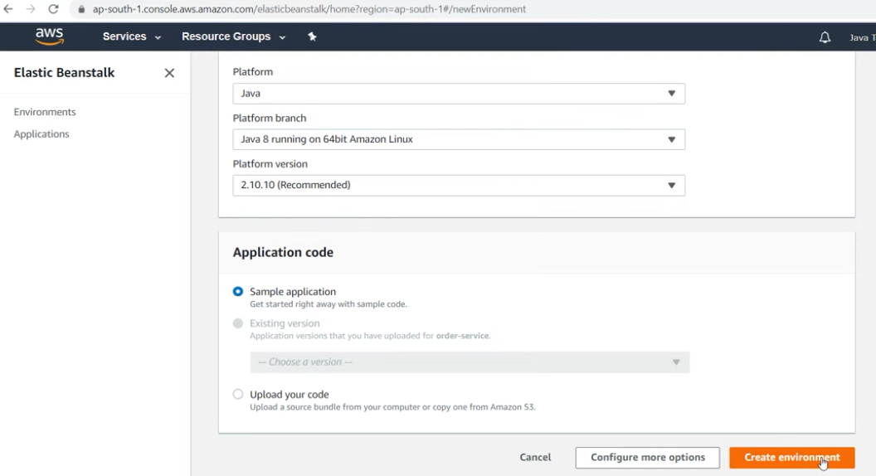

**Create AWSCode pipeline**

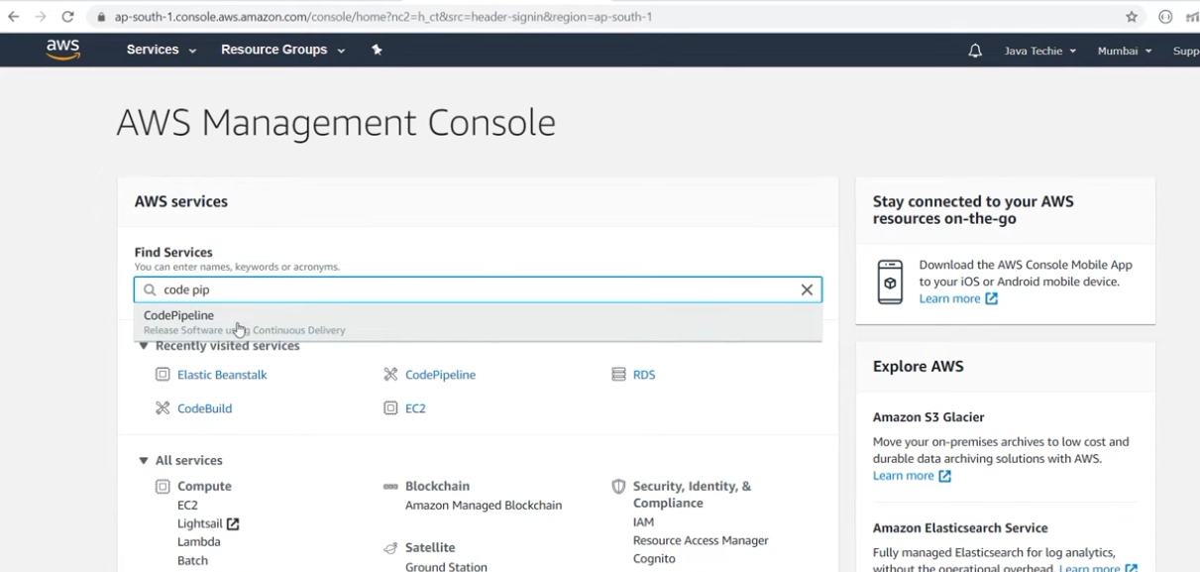

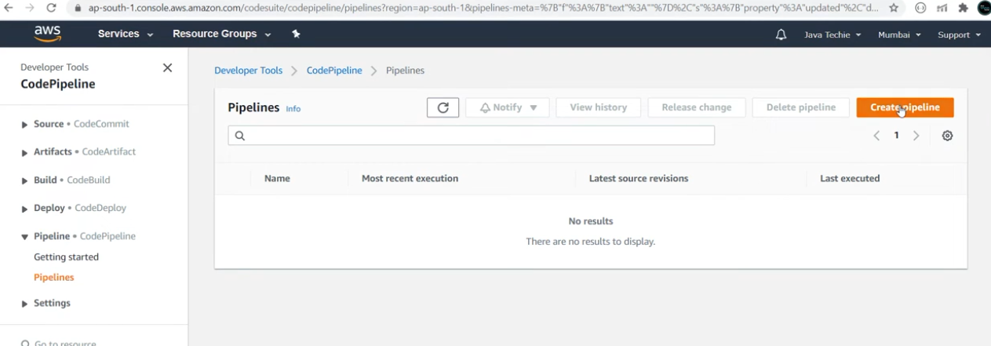

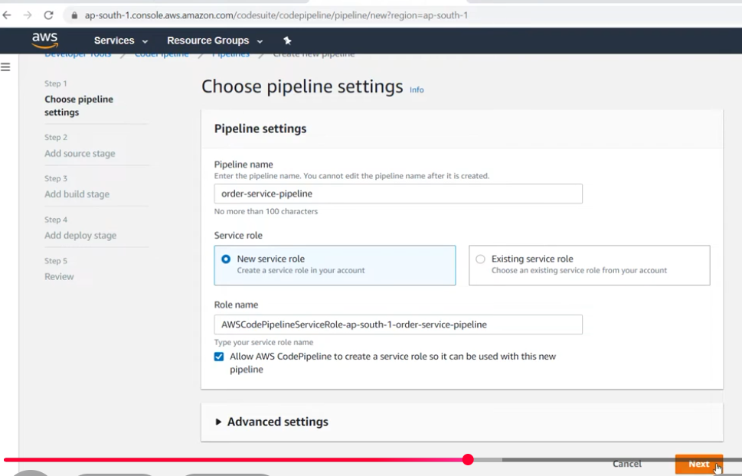

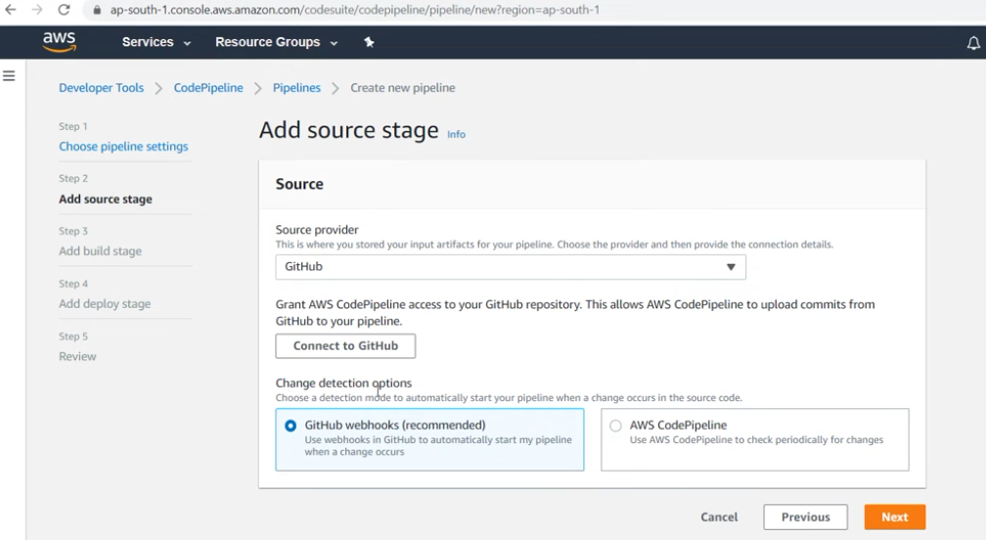

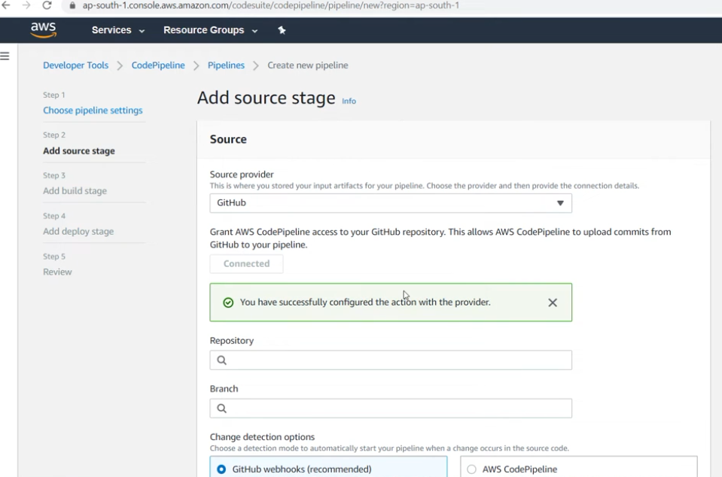

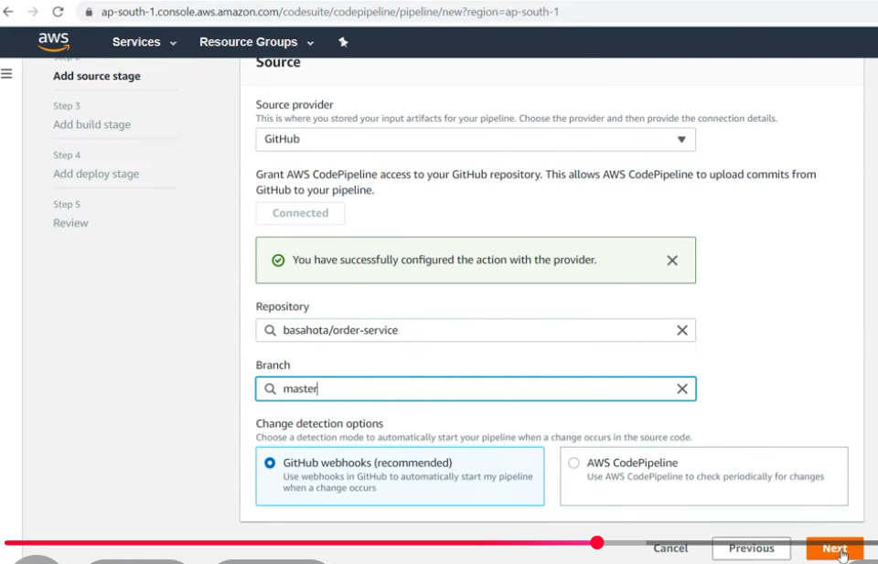

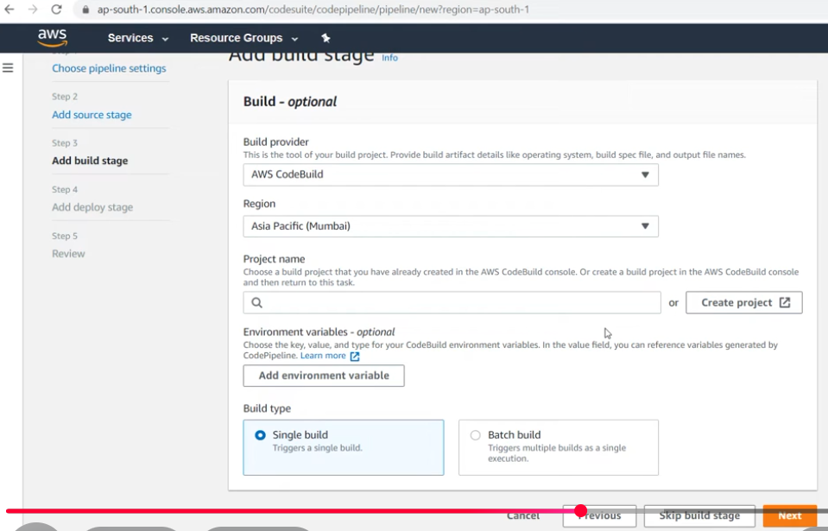

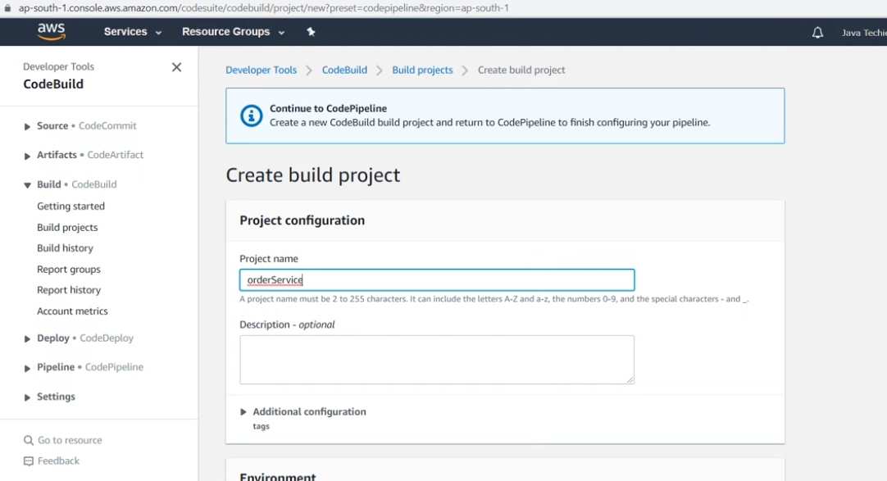

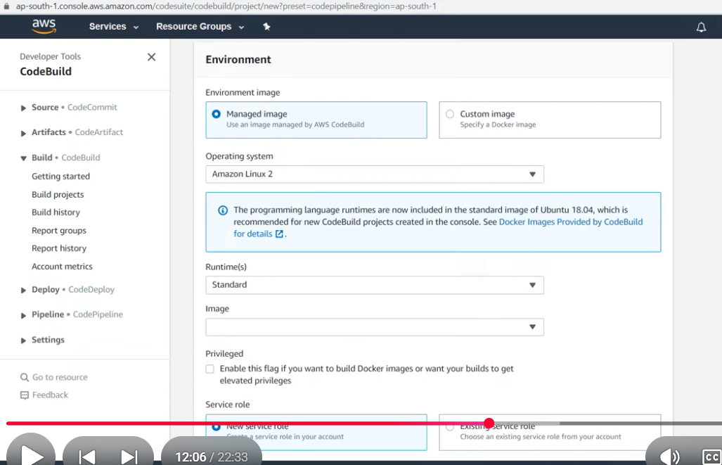

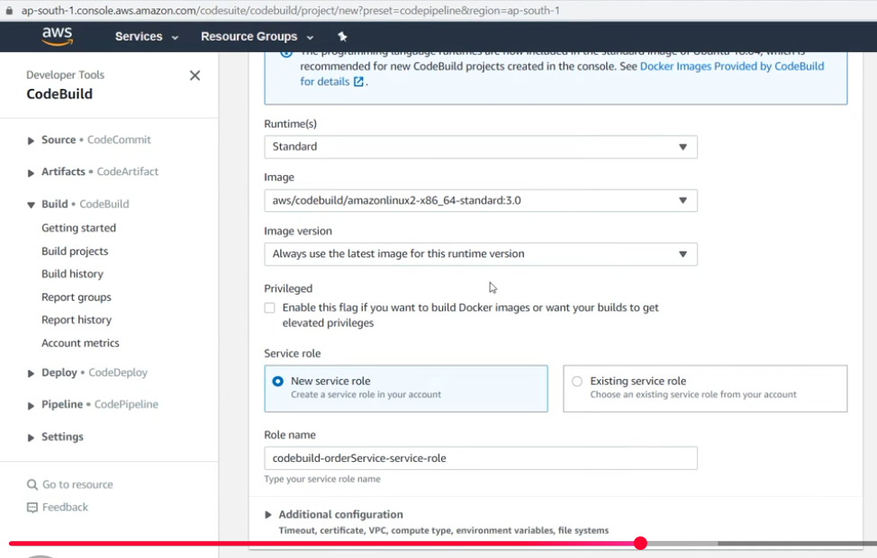

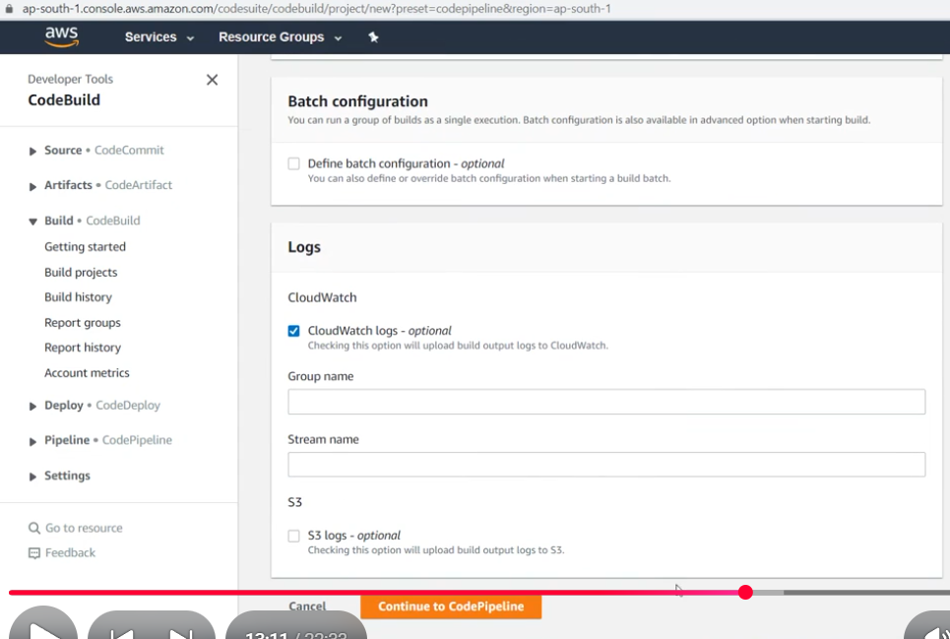

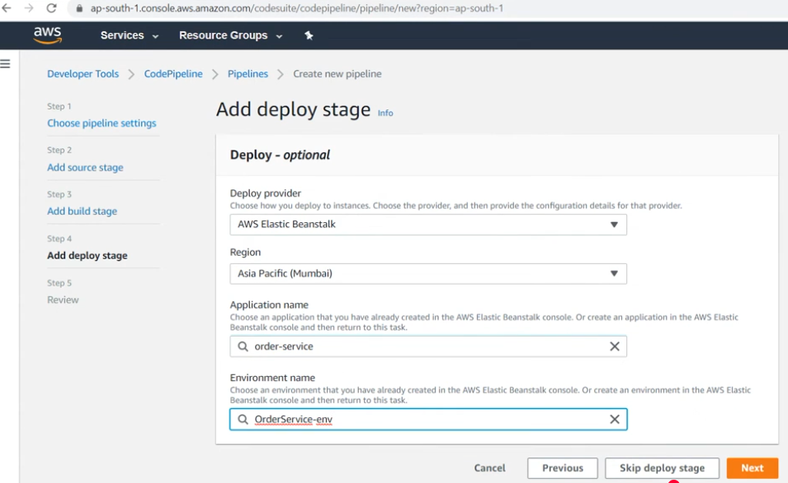

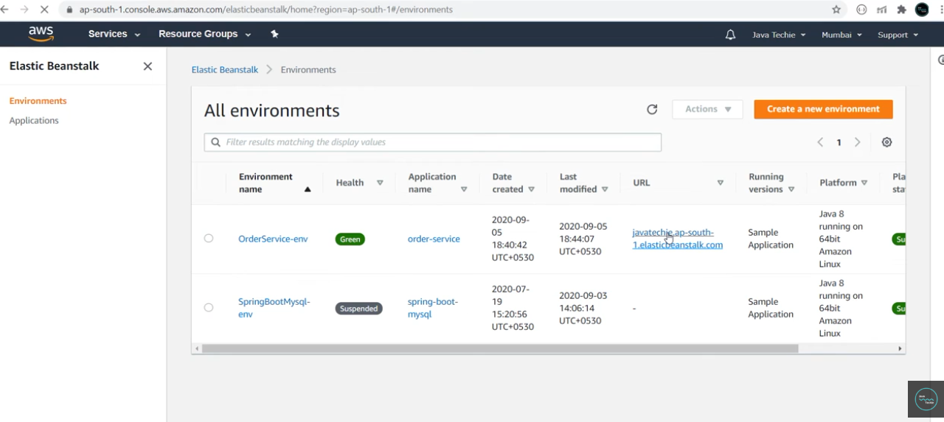

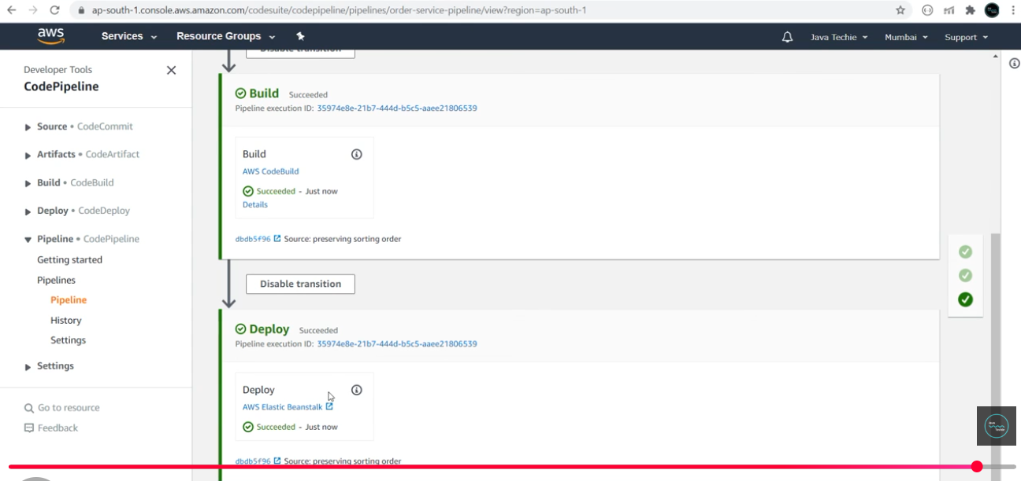

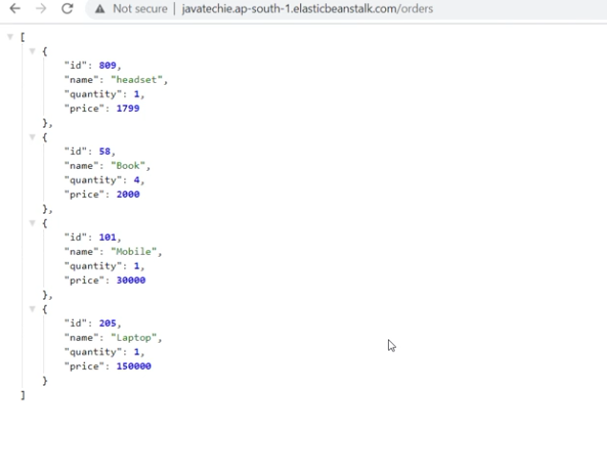

**AWS CodeBuild | AWS ECR | Build & Push SpringBoot Docker Image to ECR | ECS**

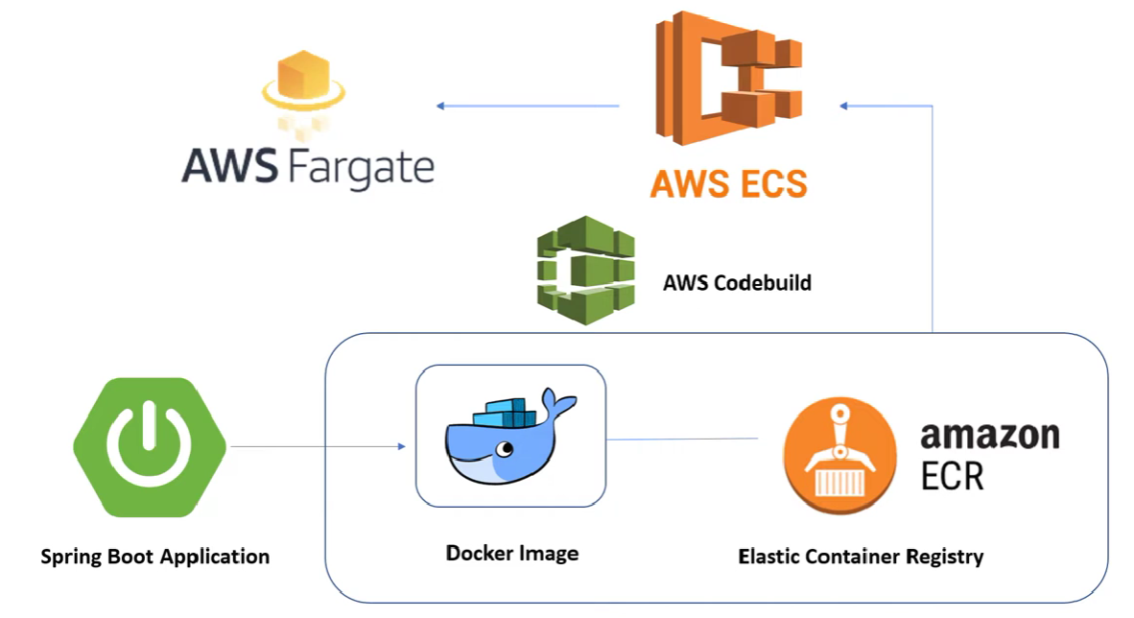

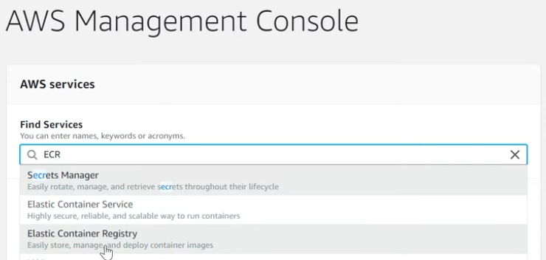

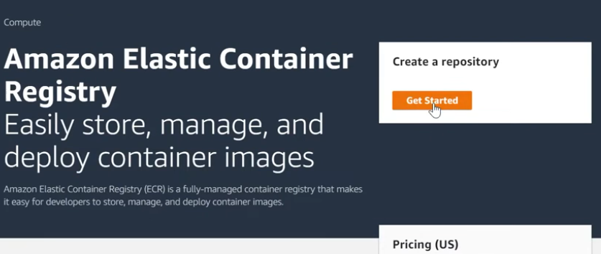

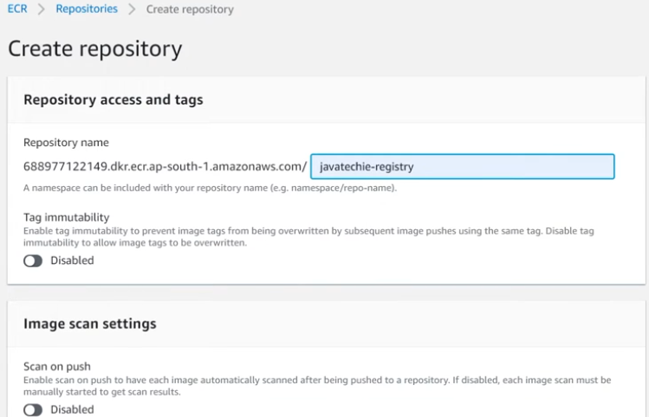

Copy URI

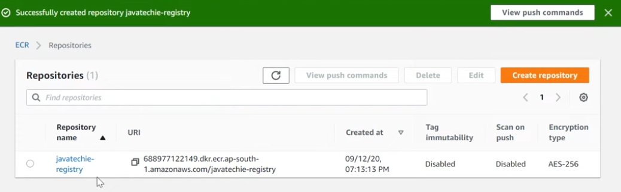

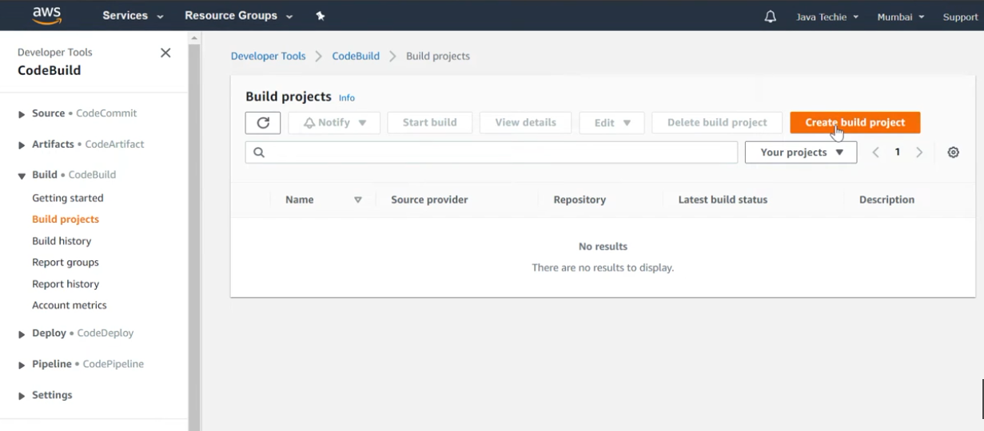

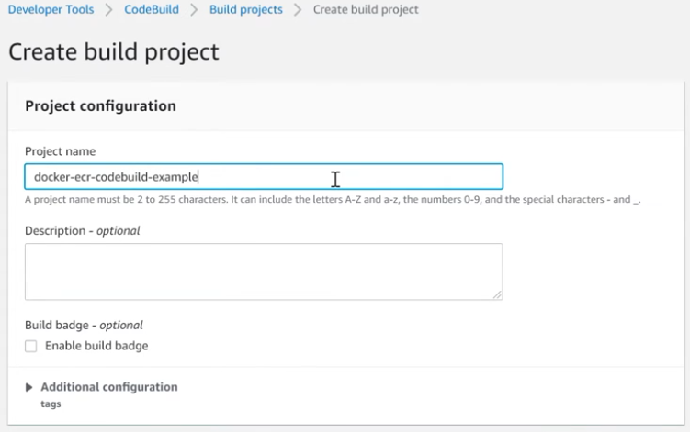

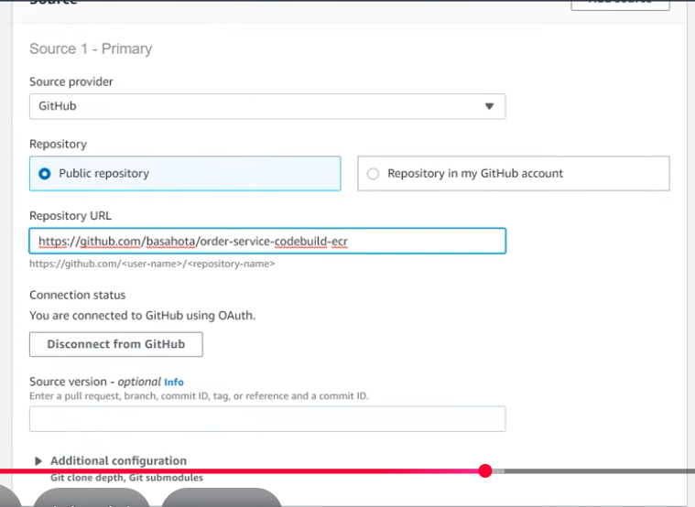

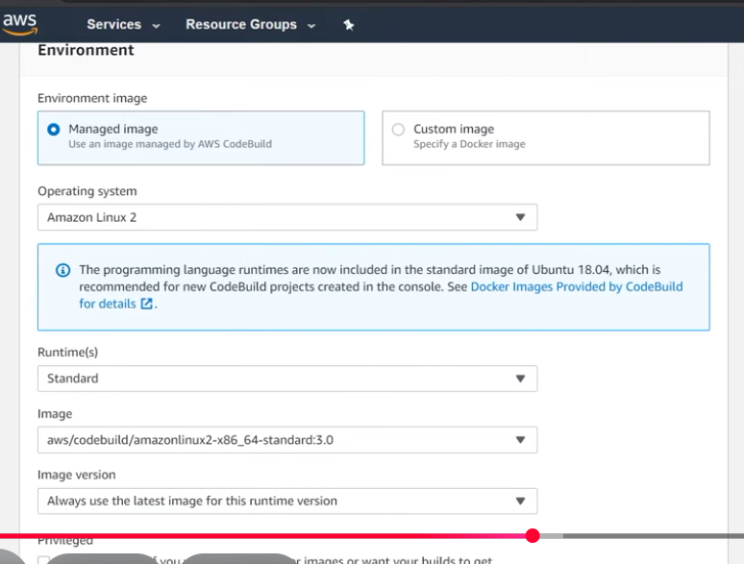

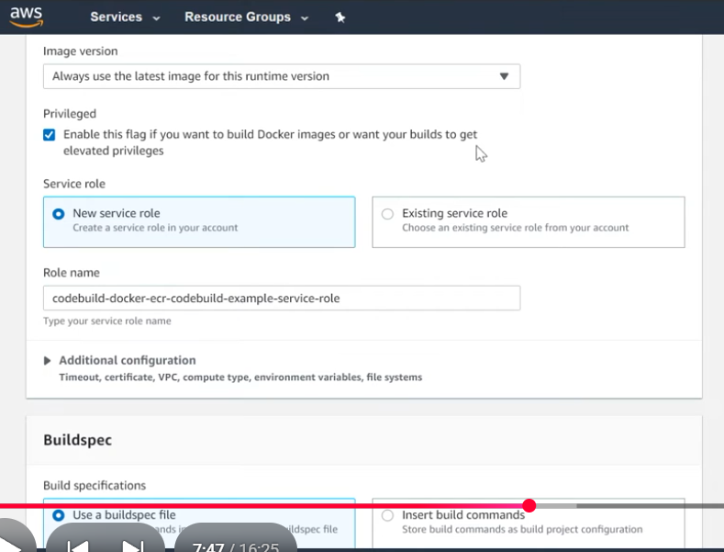

Create Role

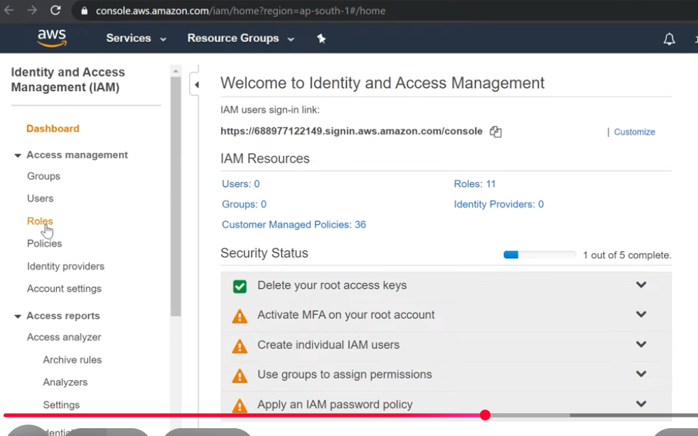

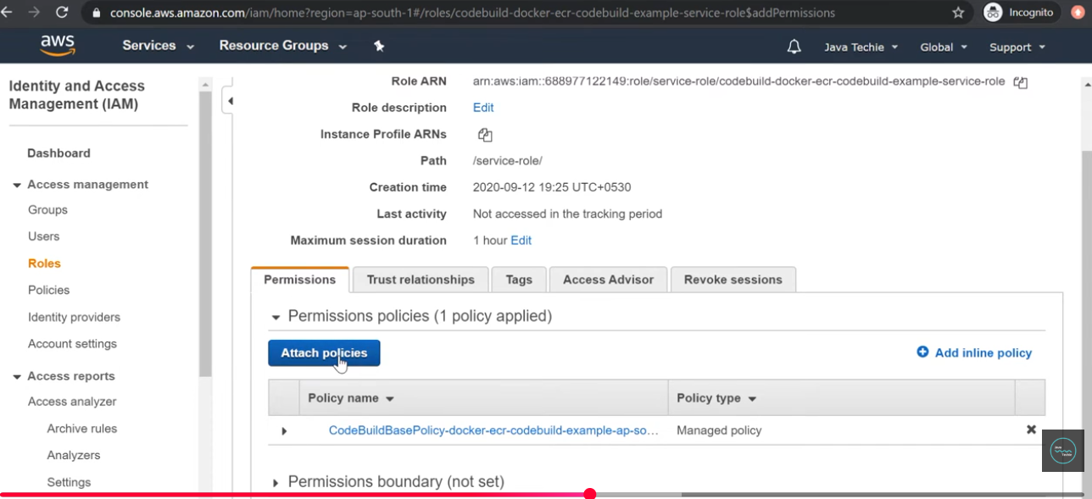

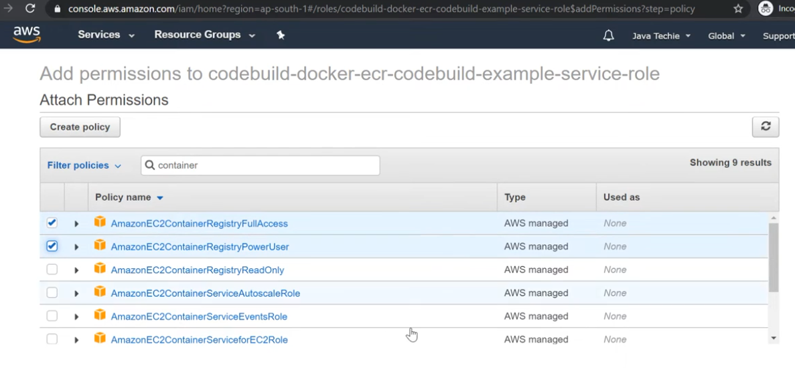

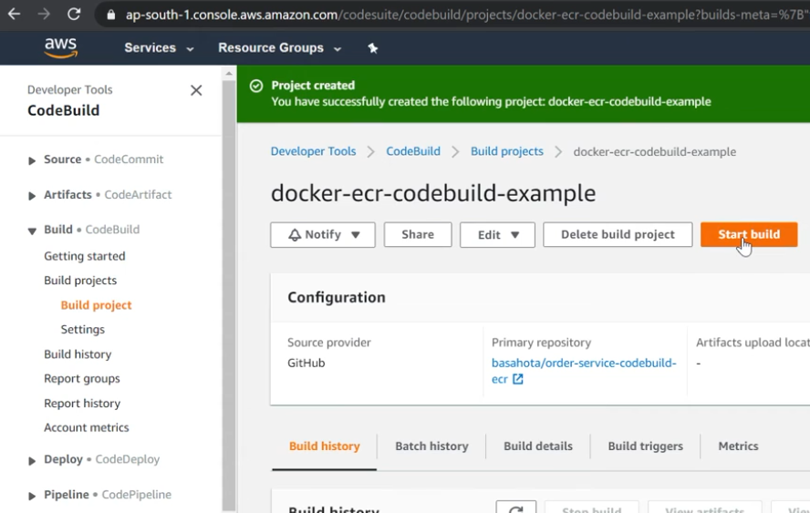

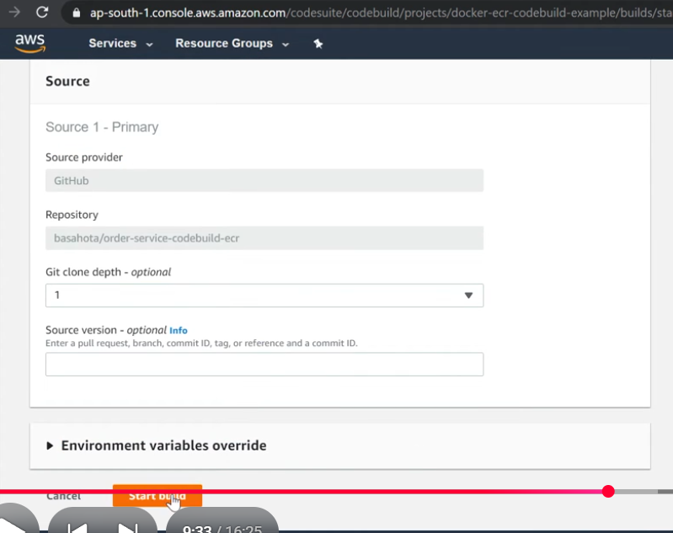

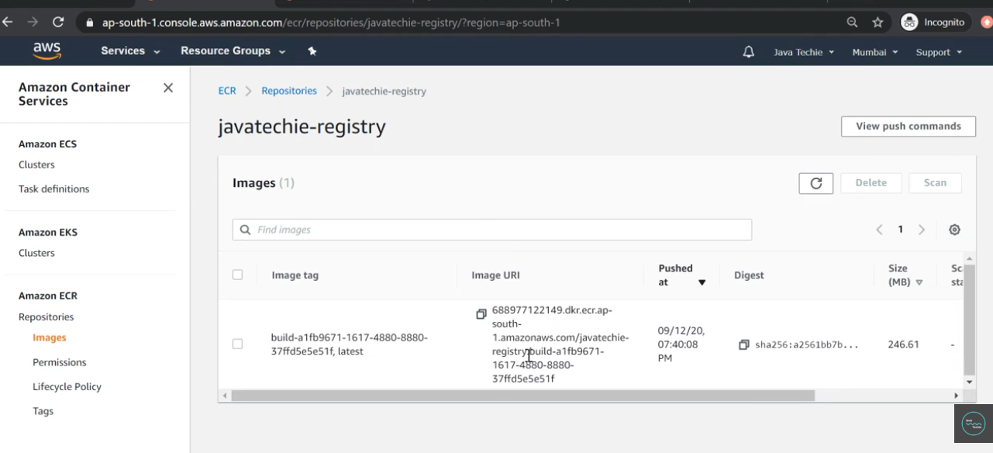

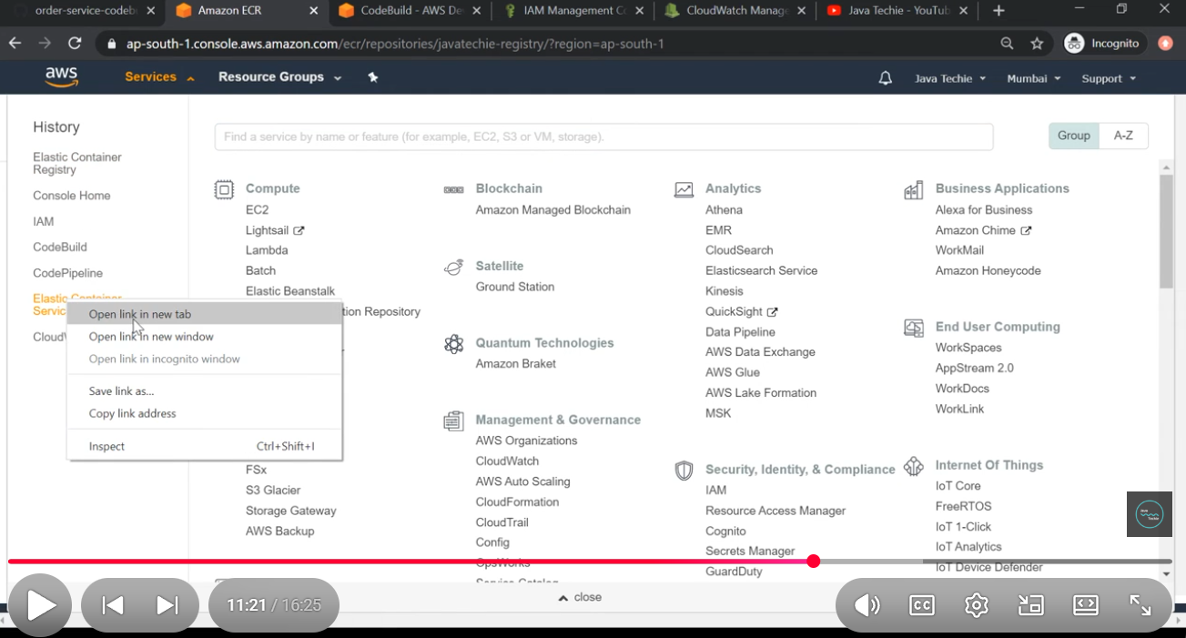

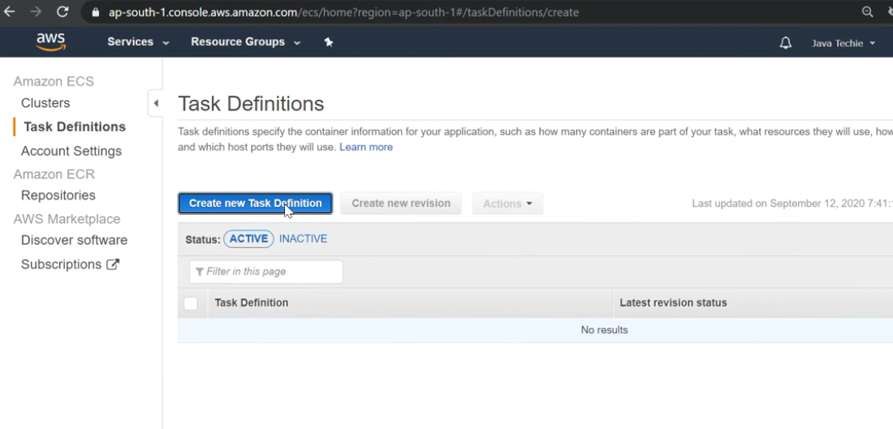

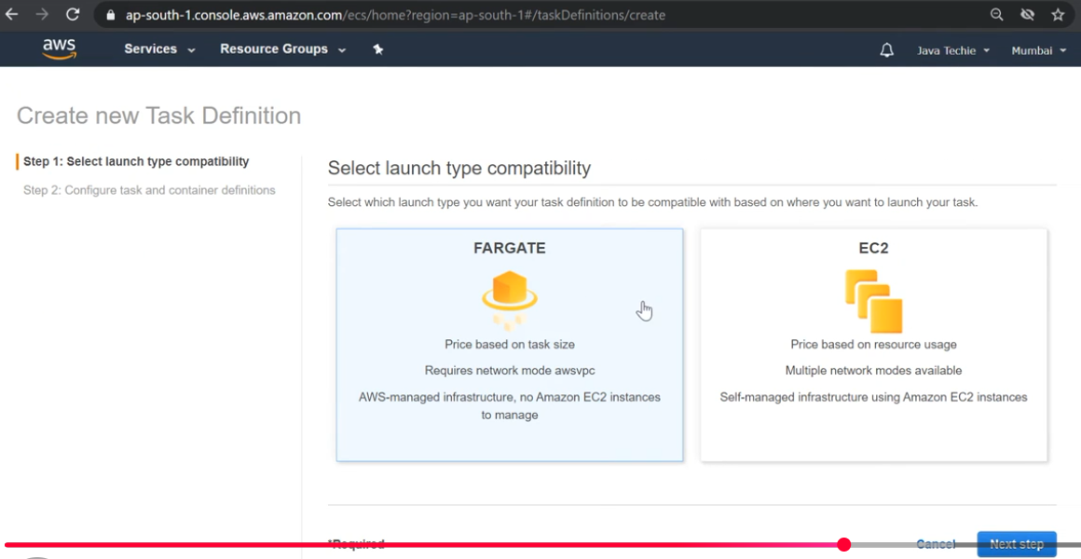

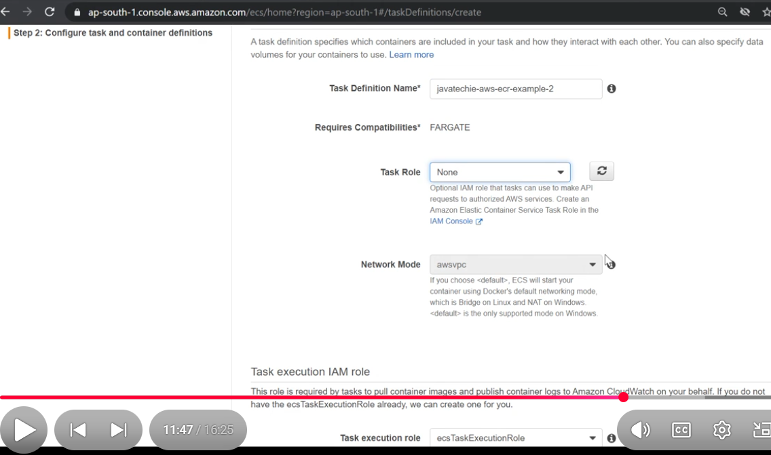

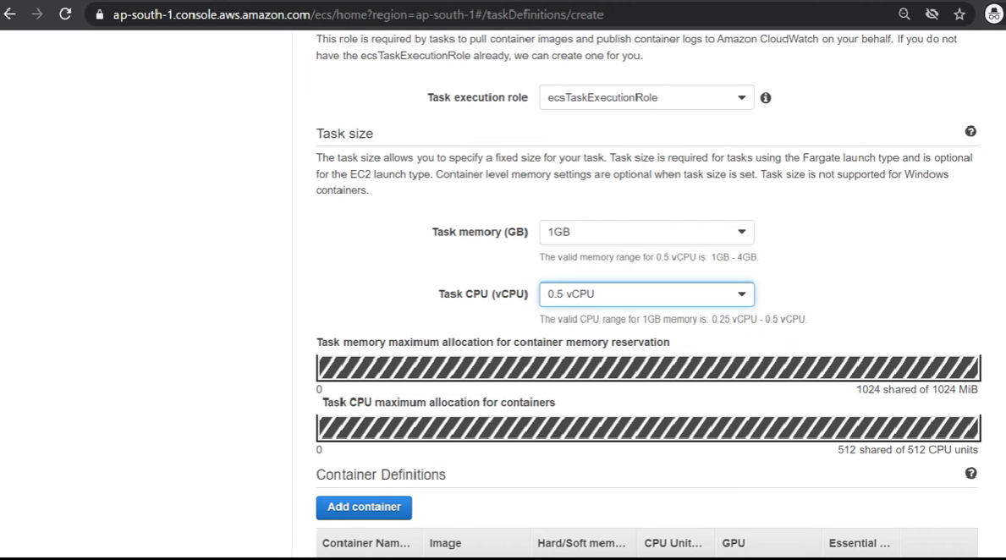

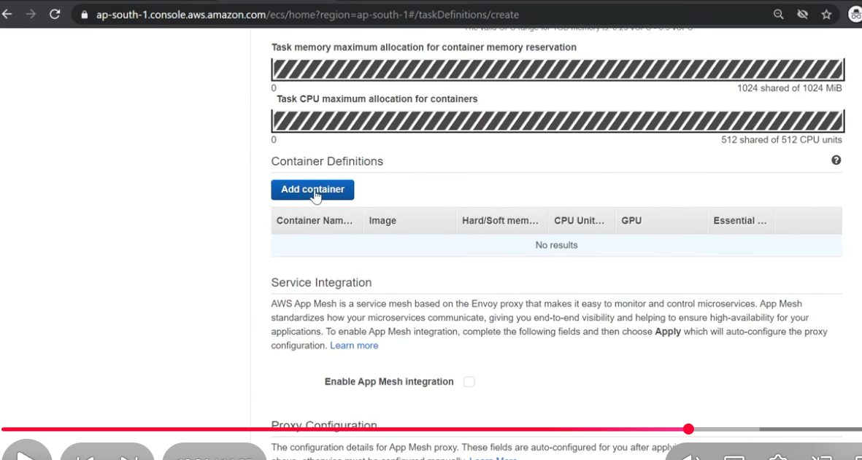

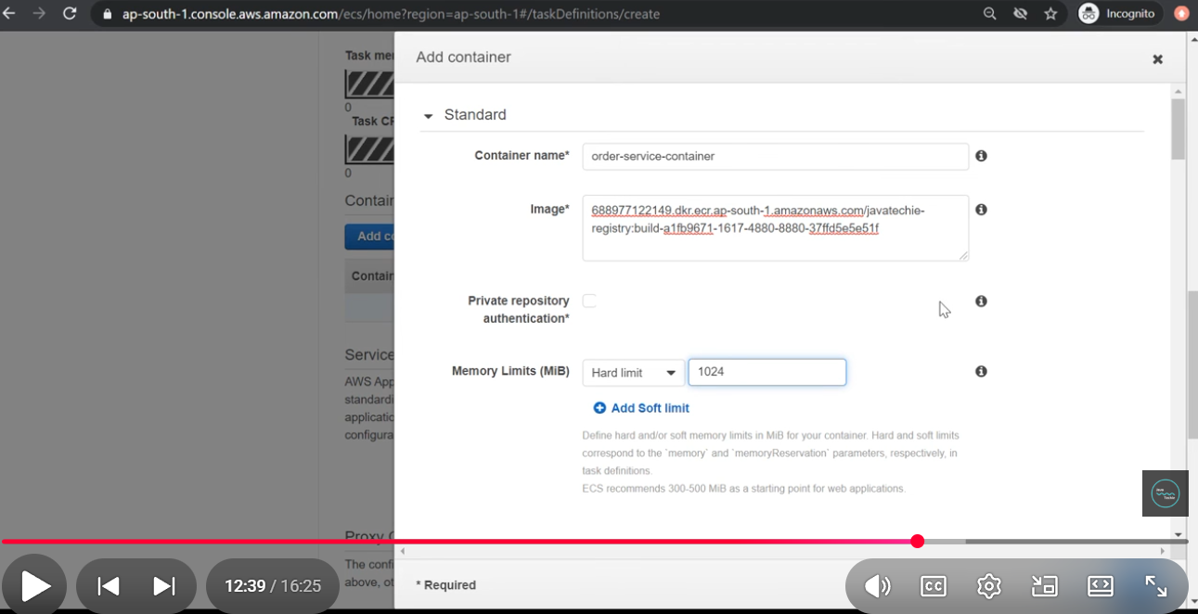

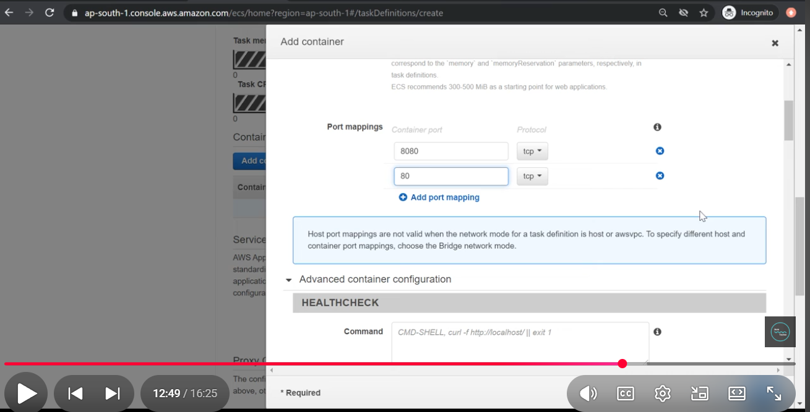

Click on create

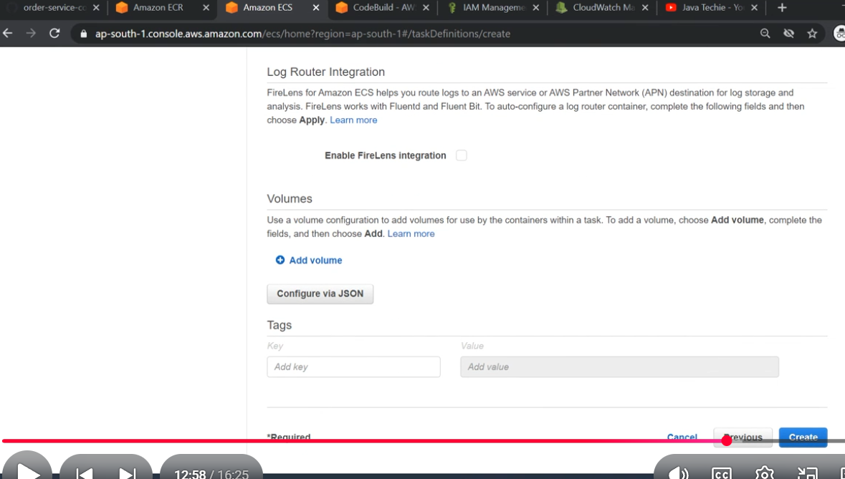

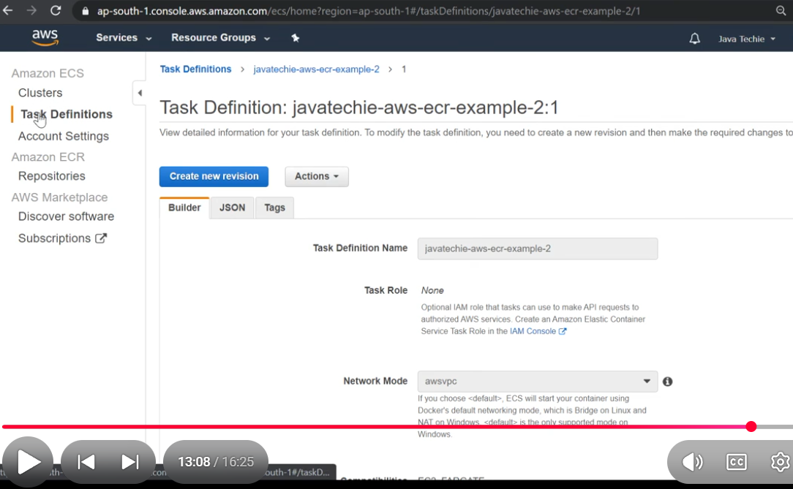

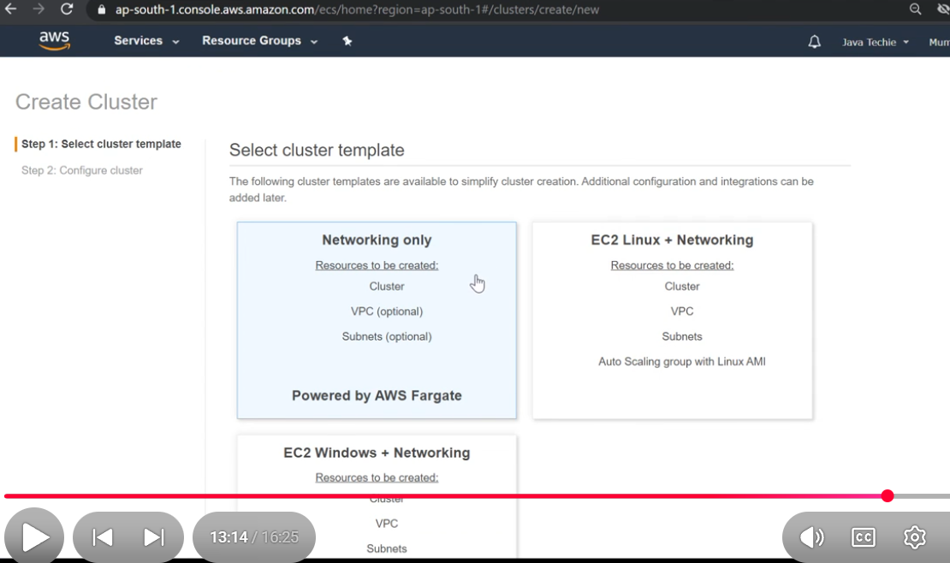

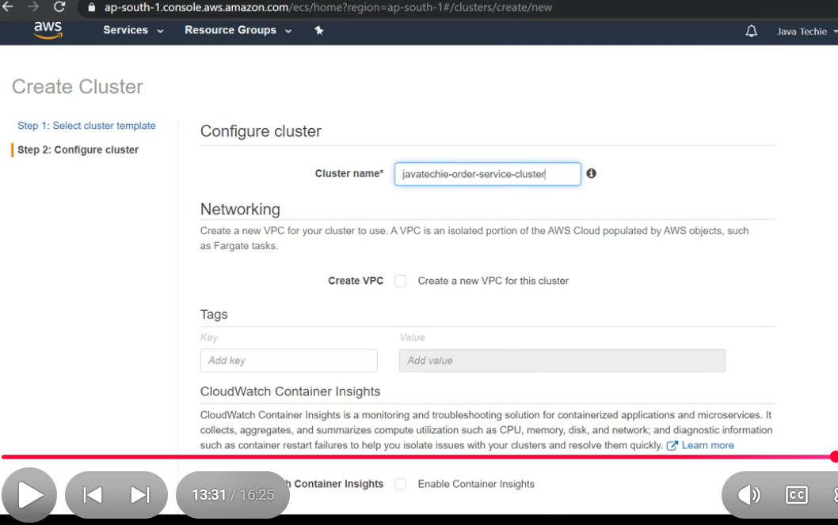

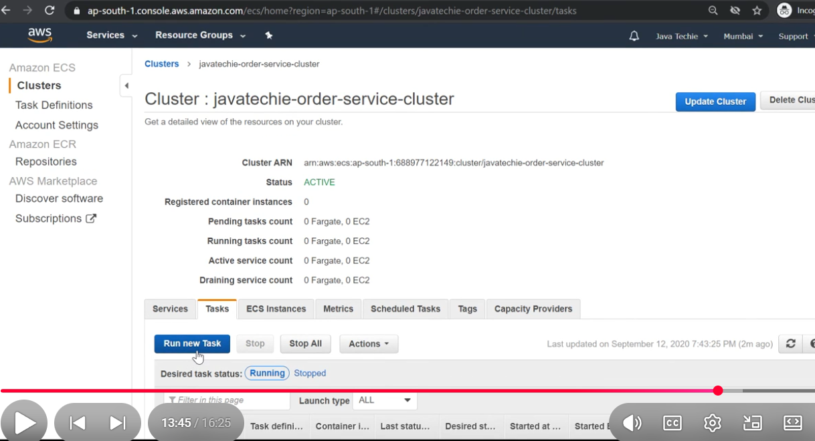

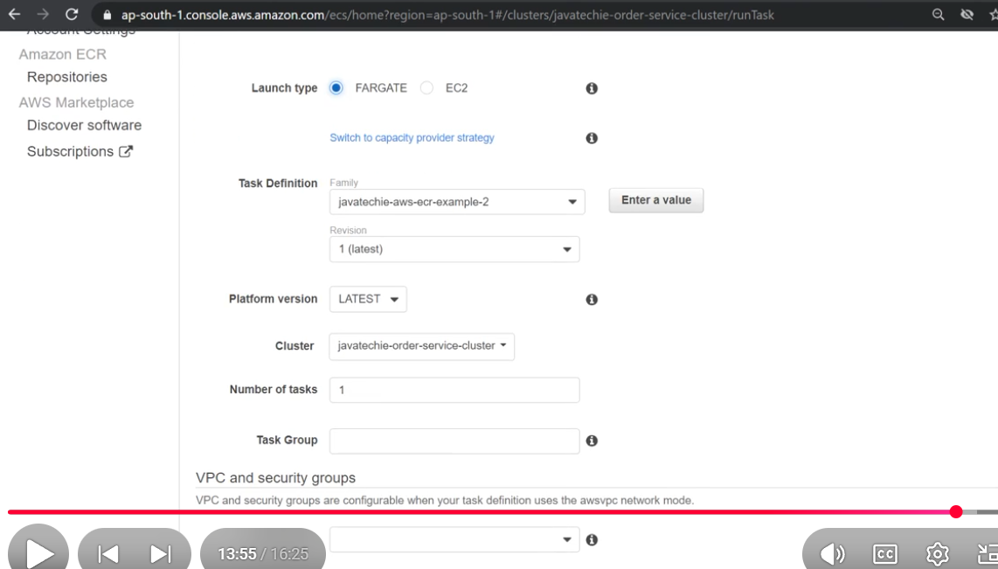

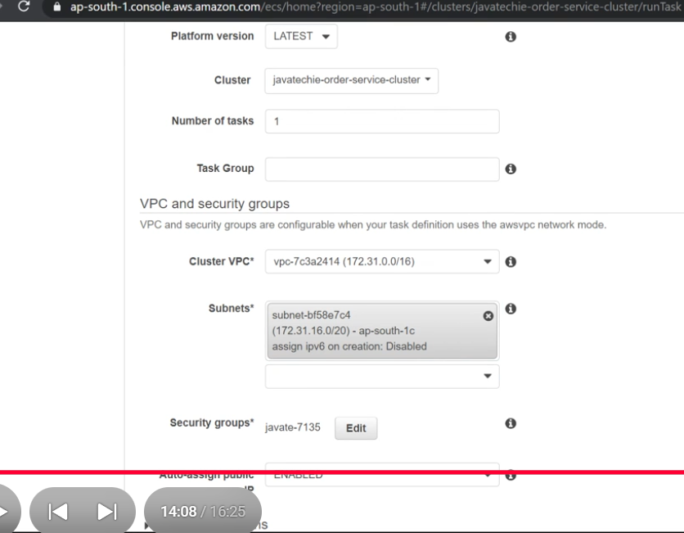

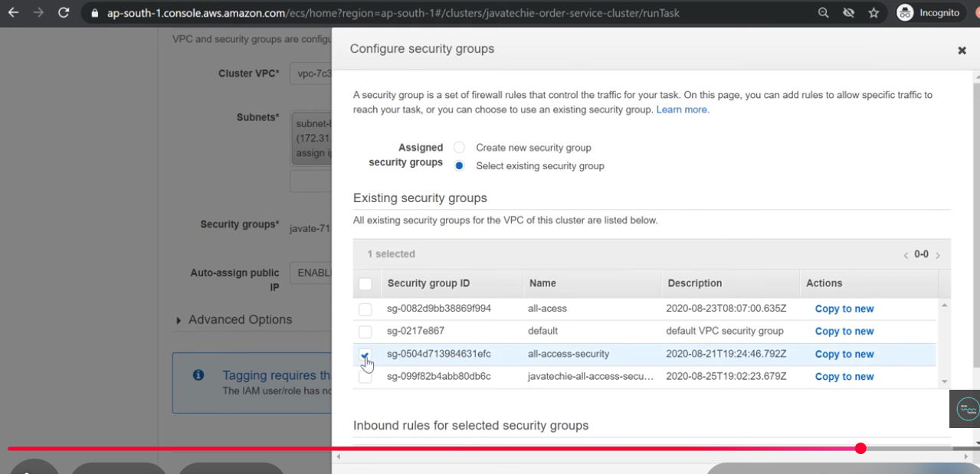

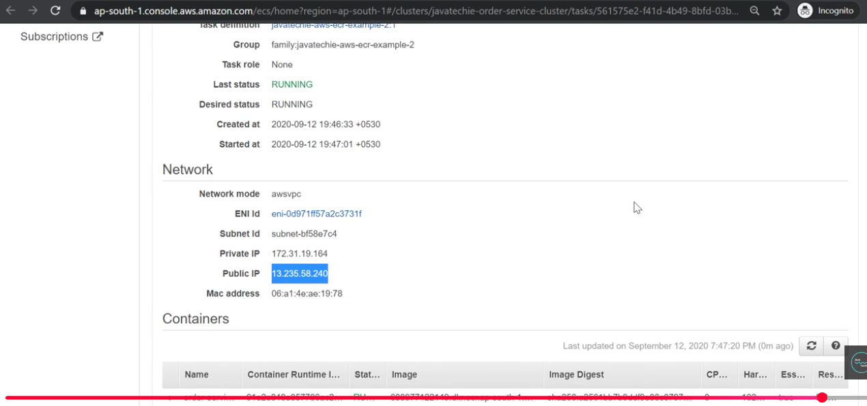

**Spring Boot With Amazon S3 : File Upload & Download Example | S3 Bucket**

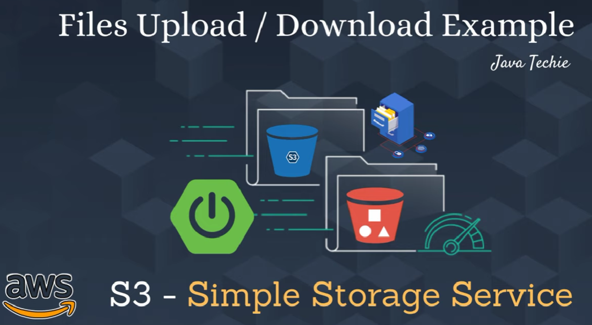

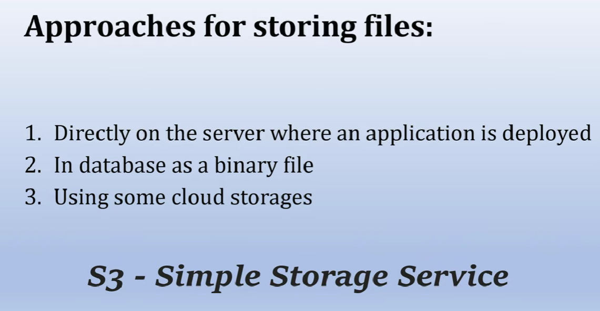

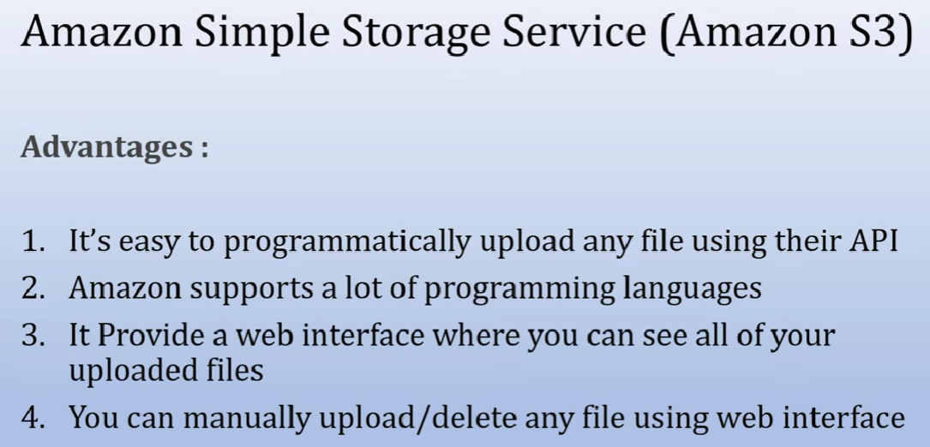

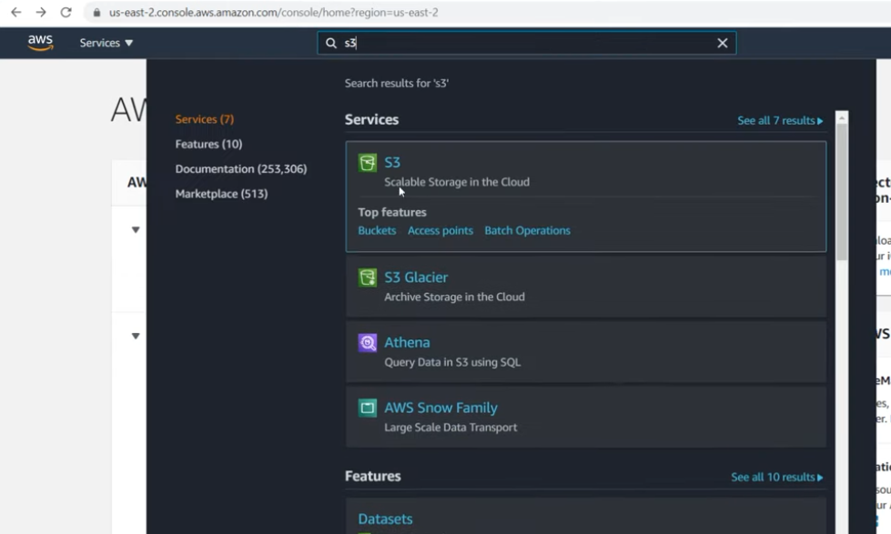

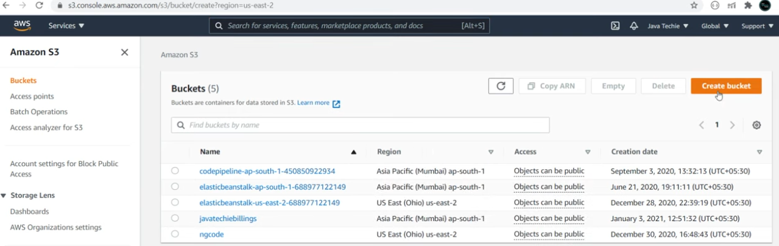

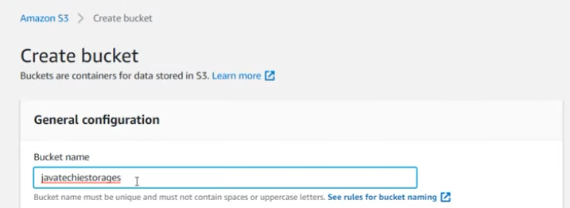

Allow public access

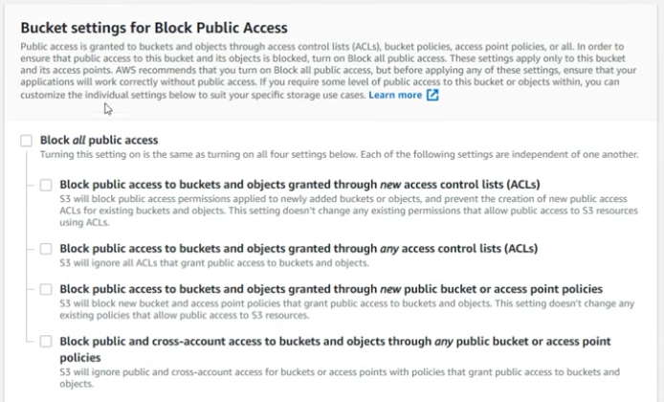

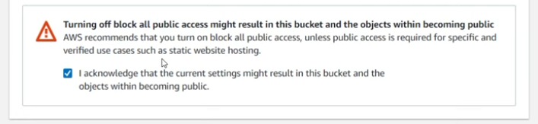



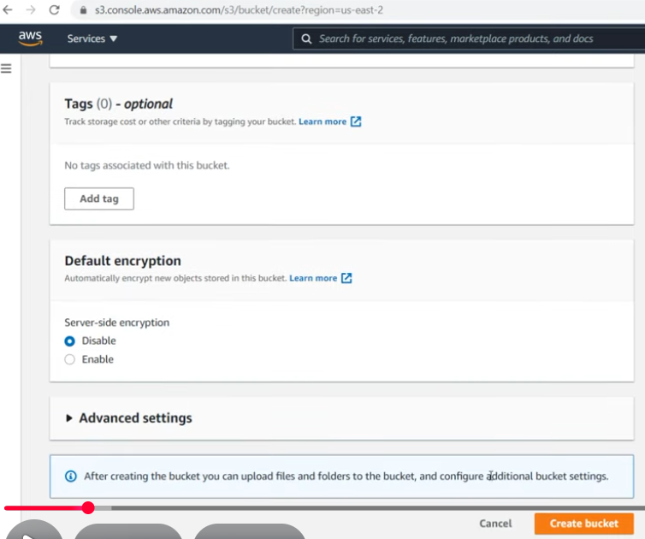

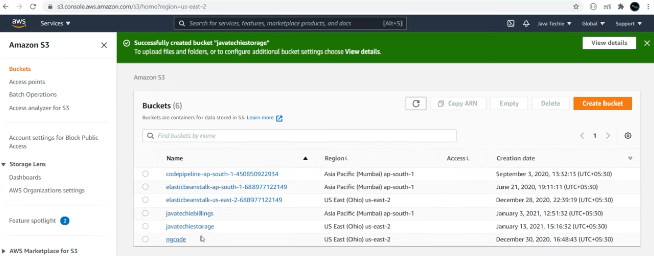

**Deploying Spring Boot on AWS EKS (Elastic Kubernetes Service )**

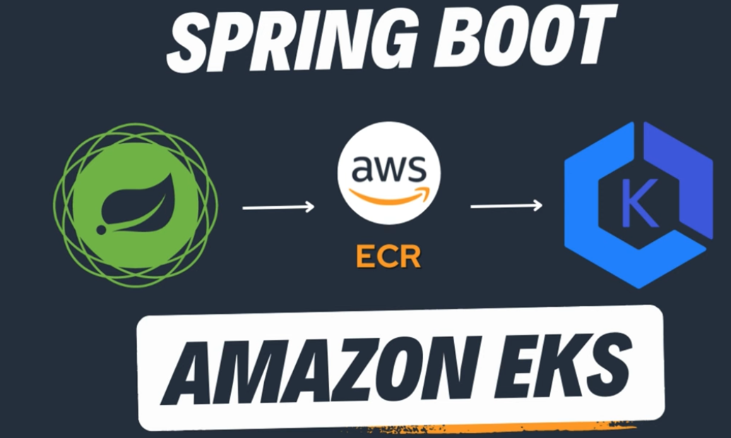

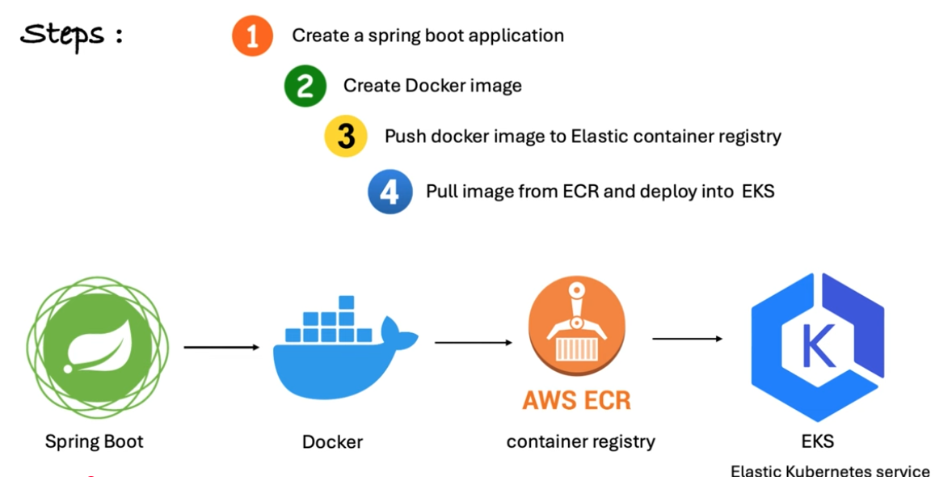

Required Following in our local machine

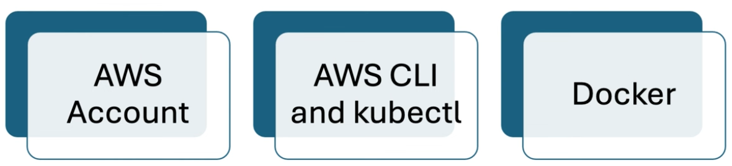

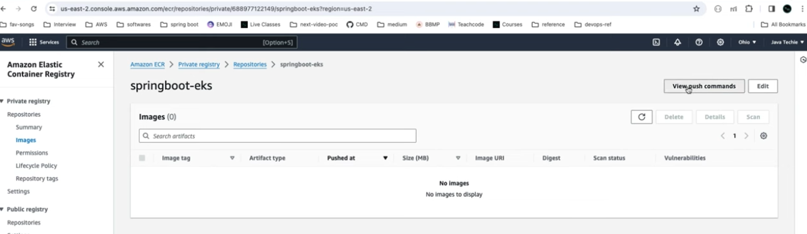

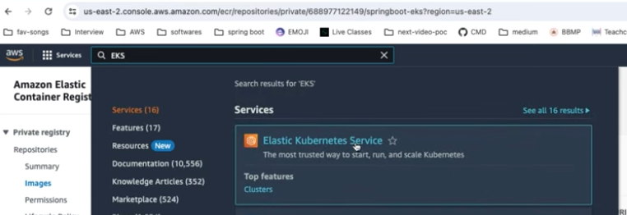

Create EKS cluster through Kubectl

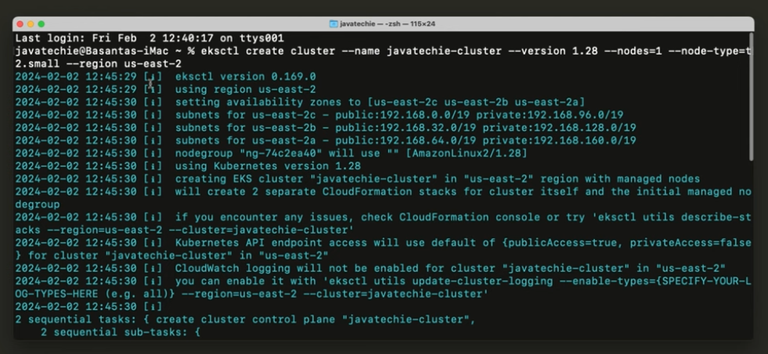

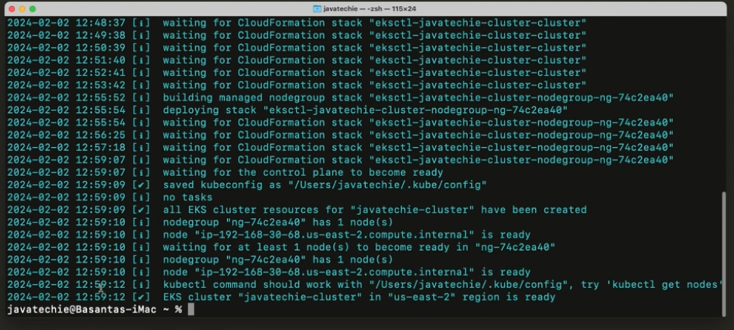

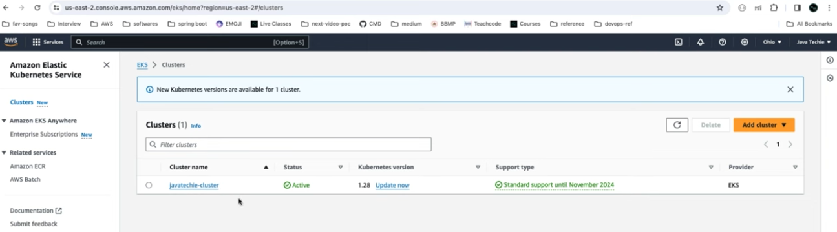

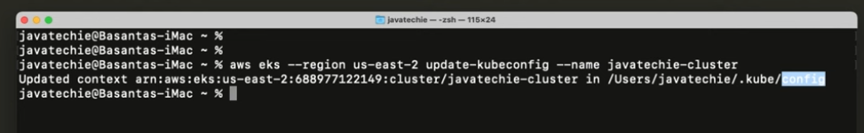

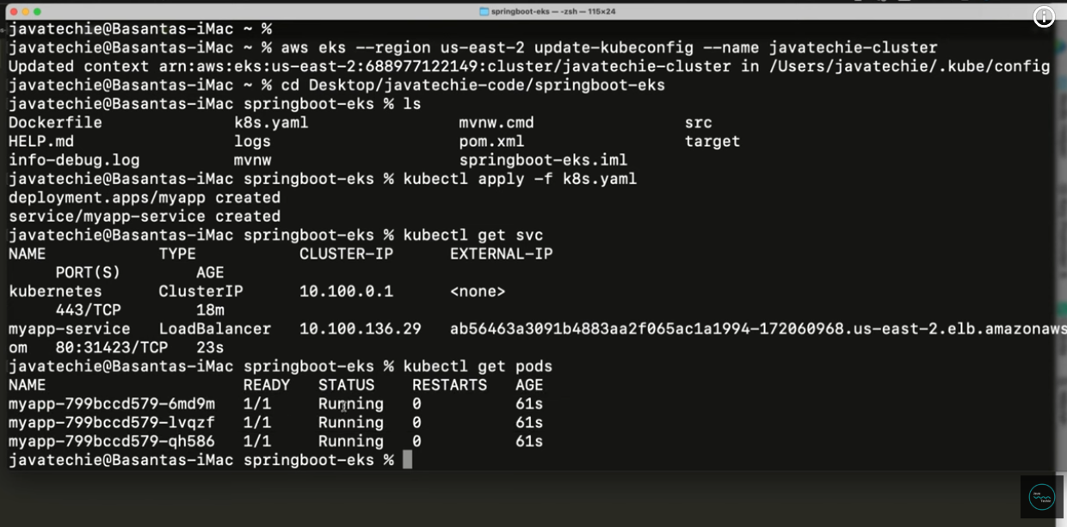

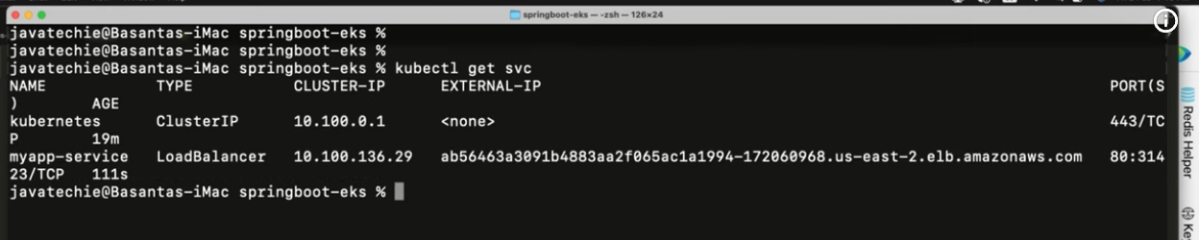

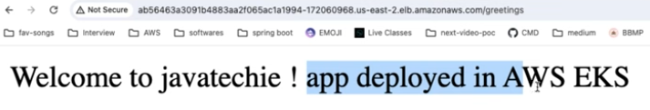

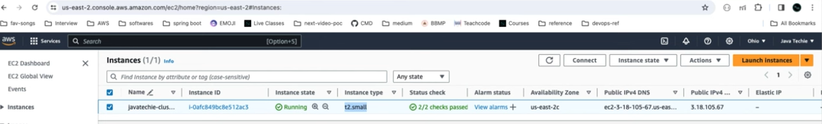

Delete Cluster ( once our job is done, why becoz it charge you )

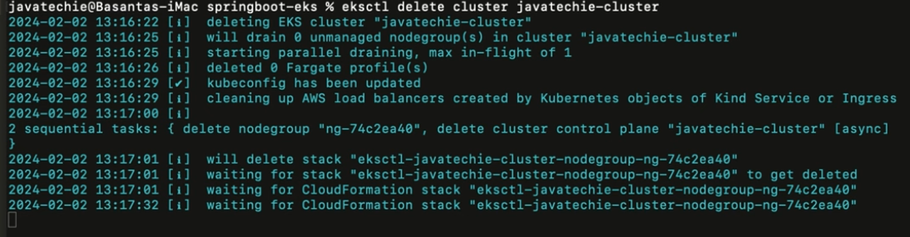

**Deploy Spring Boot Serverless CRUD API to AWS Lambda 🔥 | API Gateway**

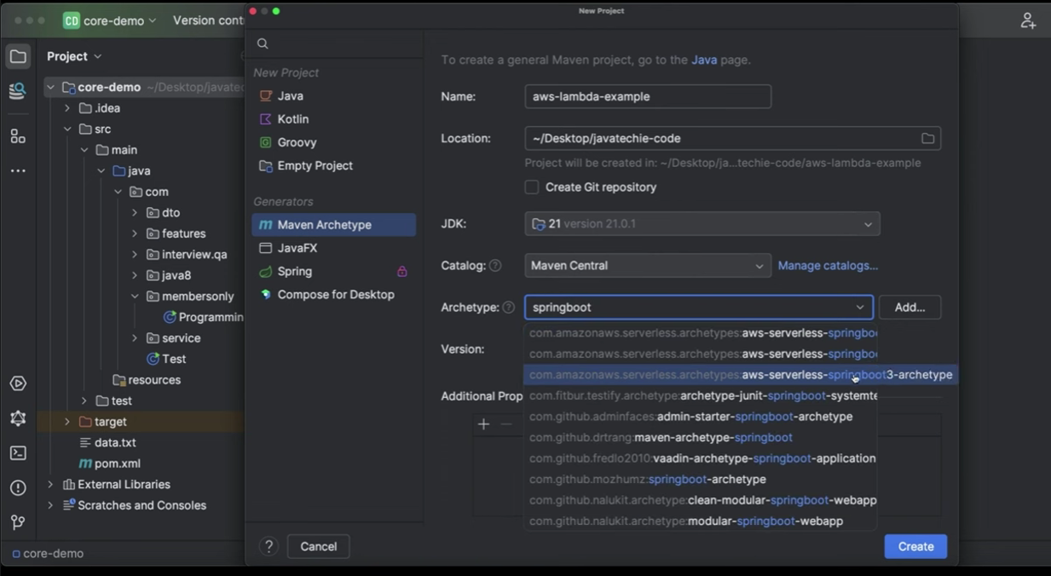

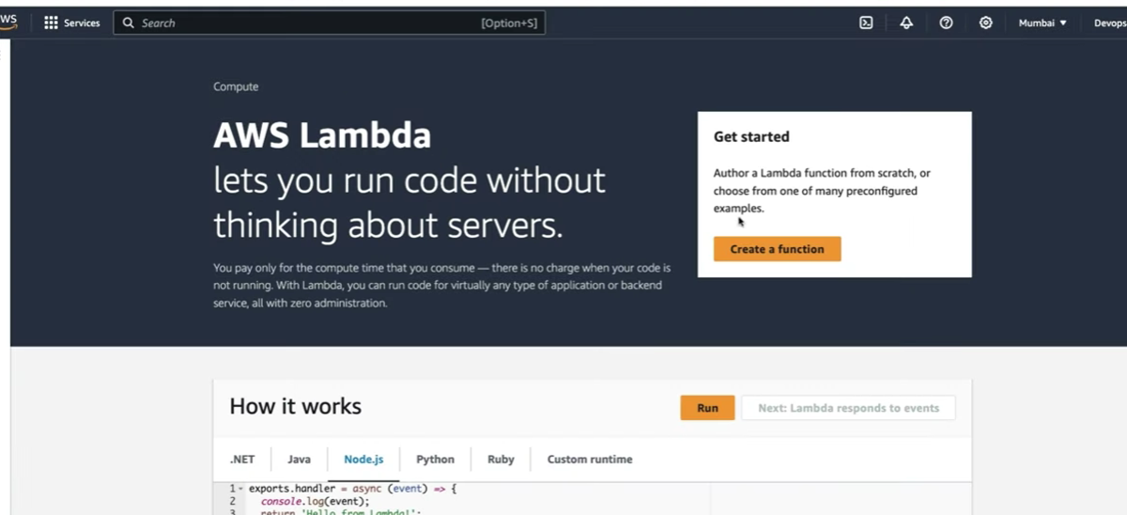

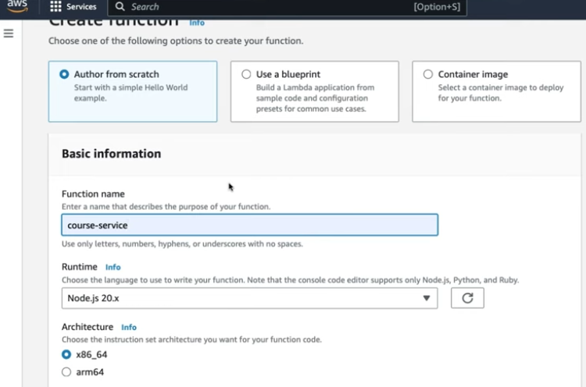

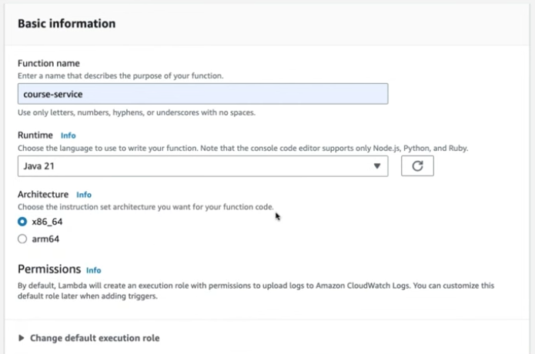

Upload springboot build given zip file which is in target folder

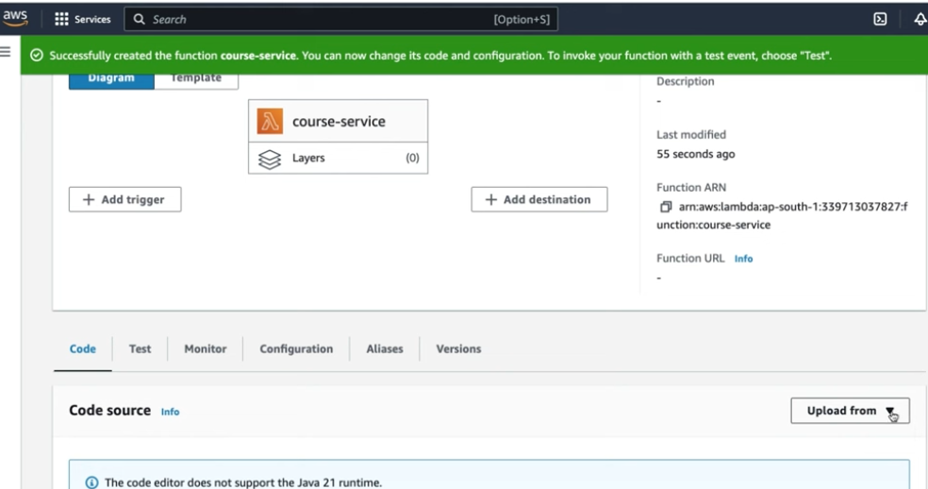

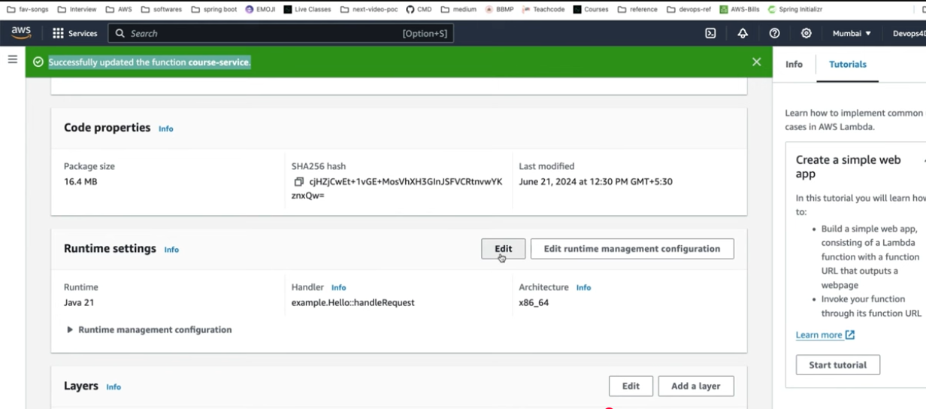

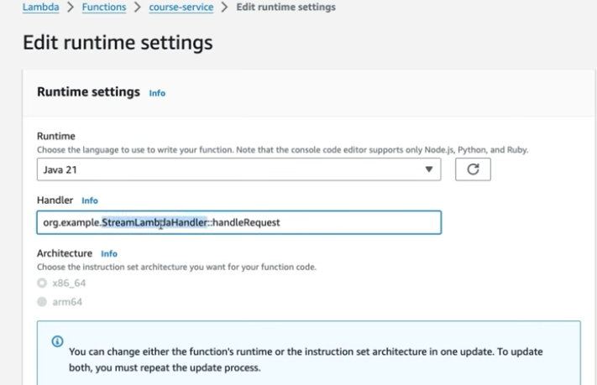

Test API

